Spanish Civil War

(1936-1939)
Global Conflict in the 20th century
By
Prim Patsatorn Yordchaiyapruk

In the history of the world, Spain was one of the important superpower countries in Europe. They colonized many countries to show how powerful they were and along with long their history and cultures that have developed overtime from generations to generations. Spain consolidated their power for many centuries. However, by the 20th century, Spain lost their power and stability compared to the successful expansion of the British Empire. Bloodshed, deaths, soldiers, weapons and violence were the conditions of the Spanish revolution, which has remained the biggest fights between two political parties and civilians.

At the beginning of the 20th century, it was a big change in Europe. Many countries were trying to get away from the monarchical government and changed their government into democracy. Additionally, many new governmental systems were introduced to people during this period, such as Socialism, Communism, and Fascism. As a consequence, it made those seek for the better governmental system to make their life better. But there were many ideas believed that democracy was a greater form of government. As a consequence, people tried to overthrow the monarch, which shifted Europe from the way it was before. This changes also influenced Spain due to the decline of Spanish king “King Alfonso VIII”

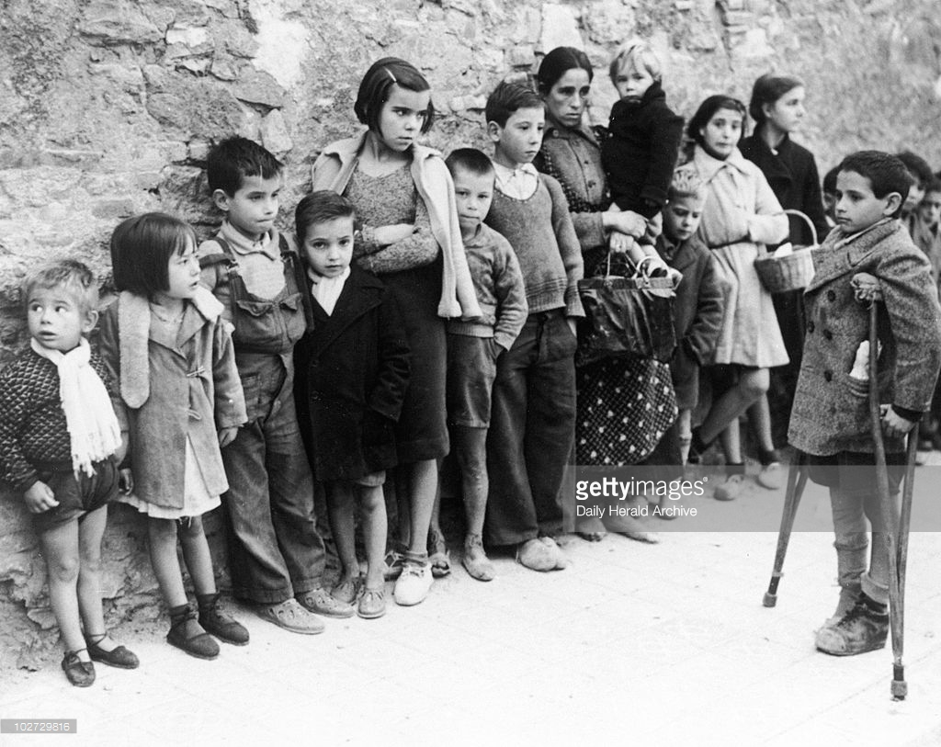
King Alfonso VIII was a person who became the first spark that created instability in Spain. Due to the king’s weak ability to govern the country, it made Spain become weaker than before. Furthermore, there were many issues occurred this time such as poverty and famine. The problems of starvation commonly happened in Spanish working class people and other issues were an inefficient economic system. Additionally, during 1929-1939 was the period of “The Great Depression” or the failure of economic systems that spread throughout Europe. Consequently, Spain got affected from the Great Depression, which it was hard for Spain to restore their economics since there was a high employment rate and many working class people were unemployed. As a result, these issues anger the civilians especially the working class people because they were the social group that had the most effect from this serious issue. People were concerned about these serious situations. So, they wanted to overthrow King Alfonso VIII. Due to this fact, they believed that there would be the better government to govern Spain than the monarch system. In 1931, King Alfonso departed from Spain by himself.

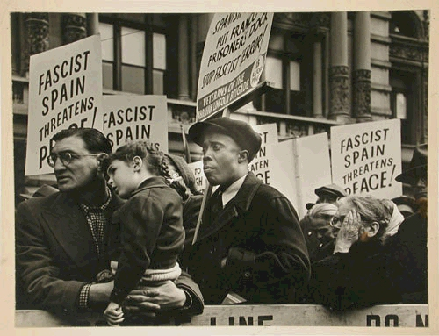
After that, there were a new republic came to power. Spain’s new republic was consisted of two main opposite group, left wing and right wing. Manuel Azana was the leader who led the left wing or “the Republicans” or “the popular front”. Moreover, the Republicans were the group of people who believed in republic and they were communist. Whereas, the right wing or “the Nationalist”. General Francisco Franco was the leader of this side. Franco was a fascist’s dictator who believed in conservatism and nationalism. In 1936, the Republicans won the election. The result of the election was the vote of the civilians. Consequently, Manuel Azana came to power as a leader of the country, which anger the Nationalist party.

When Azana governed Spain, many changes were made but these changes dissatisfied the Spaniards. These changes were people fell more deeply into poverty and depression. People had hard time living in Spain because of Famine. Although, Azana knew poverty in Spain was a serious concerned for many years but Azana didn’t fix any of these problems. Moreover, these problems had still remained in Spain. In contrast, he escalated these problems into more serious issues. After he governed the country, Spain’s agricultural price fell as well as the good export’s price. Moreover, an unemployment rate raised sharply, which it made the people to have no job. An unemployment issue was the causes that made the working class started to think against the current government and revolted. In the same time, Azana tried to get rid of the church in the country. He separated the church by not included it as a part of religion in Spain. He burned down the church and forbidden the religious curriculum in school and not allowed nuns and priest to teach. More than that, he stopped paying the nuns and the priests’ salary. From his actions, people and the religious person were dissatisfied. Not just that, in that time, the economic went bad and the capitals went out from the country due to the Great depression. Spain’s economy was getting worse because the money didn’t flow well in the country and they also lost the money to other nations. In addition, many soldiers officer got retired to reduce the army to reduce the country’s expense. From these actions, this causes the army to be weaker than before. The Nationalist group was unsatisfied about the Republicans because they were weak. So, the Nationalist planned to revolt against the republicans. Franco knew that the best way to get rid of the Republicans was to use the military attack against them, which involved of violence.

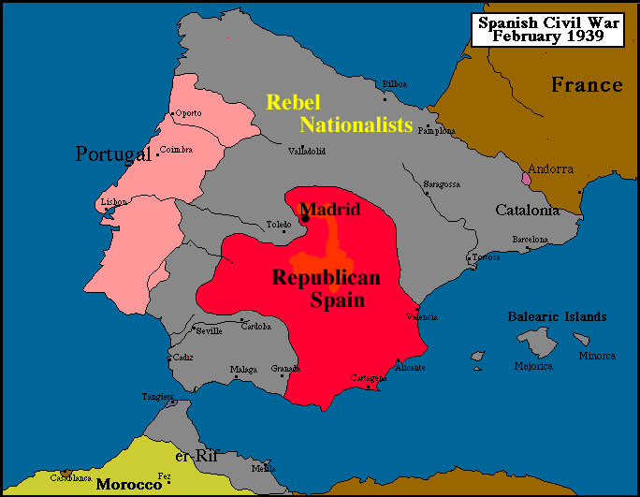
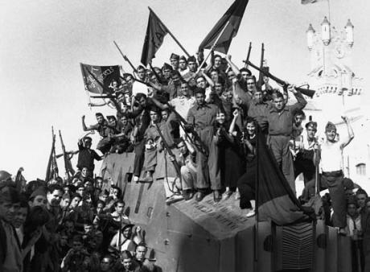
In 19 July 1936, the republicans’ police murdered the right wing’s leader of the Spanish Action Party, Calvo Sotelo and this situation made the Nationalist party to declared revolt on the Republicans. This situation led to the uprising of the civil war. The Republicans army or the Peninsular army was in the mainland. Their troops consisted of 120,000 poorly trained soldiers (Namm A., 2003). On the other side, Franco’s troop was in Morocco. It consisted of 34,000 men who were good in battling from the colonial conflict (Namm A., 2003). Franco also got the help from the Spanish Foreign Legion units, which was an organization that Franco had served before. According to this, this was the reason that major of the African were in the Nationalist side. There was also about 25,000 well-trained military officers joined Franco’s troop. Further, the Republicans army was weaker than the Nationalist’s troop. They have no well-trained military and bad weapons. According to George Orwell’s note “Looking back on the Spanish War”, “I had gone out to snipe at the Fascists in the trenches outside Huesca. Their line and ours here lay three hundred yards apart, at which range our aged rifles would not shoot accurately”(1943). It could tell that the Republicans’ weapons were old and it might not good enough for the Civil war. These old weapons made the soldier shoot at the target inaccurately along with the bad coordination between soldiers. Moreover to what Orwell had written, “Everyone believes in the atrocities of the enemy and disbelieves in those of his own side, without ever bothering to examine the evidence. (1943)” From this it could tell that many Republicans soldiers were afraid of the fascist side. They were not sure about their armies and the weapons they had whether it was good enough to fight with the fascist because they had the weaker troops. According to what Adam Namm wrote, “the Nationalists had better organization, control, assignment of appropriate ranks to officers, regulation of supply routes and the provision of principle items used by the army. (1943)” In contrast, the Nationalist side was more ready for the Civil war. They had better troops, organization, and supplies due to their ability of military in the troops. As have been mentioned before, most soldiers of the Nationalist came from the organization, which have been trained for fights. So, this was more advantageous for Franco because better troops could escalate the chance of winning. In general, the Nationalist seemed to be the winner of this game compared to the weak troops and the bad organization the Republicans had.

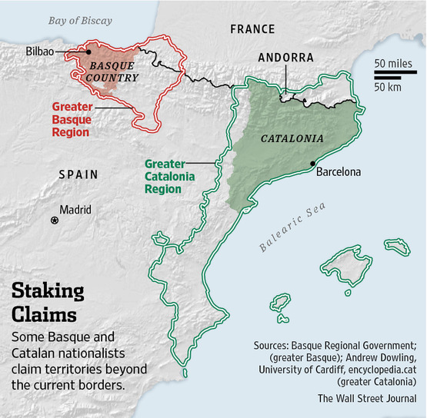
In this Civil war, the Nationalist had more roles of overthrowing the government than the people. Franco moved his troop from Morocco to mainland Spain. More than that, Franco’s troop created the bad situation of bombing to frightened people and made the Republicans lost their power of controlling the nation. Franco’s troop started to bomb the civilians in many cities of Spain. They also used the military and weapons that was supported from Germany and Italy. They started the Civil war by attacked the people to destroyed people’s support of the Republicans. Even more, the Nationalist got the help from Germany to bomb Basque area. Franco used civilian’s hatred to gain the support of the Nationalist. To clarify, the Spanish civilians hated Basque and Catalonia because they thought Spain would broke if Basque and Catalonia were support by the people. Franco also believed that both Basque and Catalonia were not part of Spain. However, the Republicans gave Basque and Catalonia freedom to govern their own and supported them. On the Republicans, they responded to Franco’s invasion by bombing the church, which it brought the situation to be worse. Also, they fought back the Nationalist by using their military forces. But when they fought back, it clearly showed that the Republicans were much weaker than the Nationalist in terms of their plan, command and troops.

In that time, working class people were the group that responded to the civil war the most. They hate the Nationalist group but they also hate the Republicans, either. In their perspective, they revolted due to their bad living conditions and poverty. People couldn’t bear and made these issues to remain in Spain anymore. For many years, labor strike existed which showed that they were unhappy but they weren’t any changes. So, they tried to get rid of these parties and wanted to restore Spain. This time was the most violence revolted the people did to bring changes. Conversely, many of them were frightening when the two parties bombed the city. There was bloodshed around. Many of them tried to get away from Spain for the reason of bombing and violence.

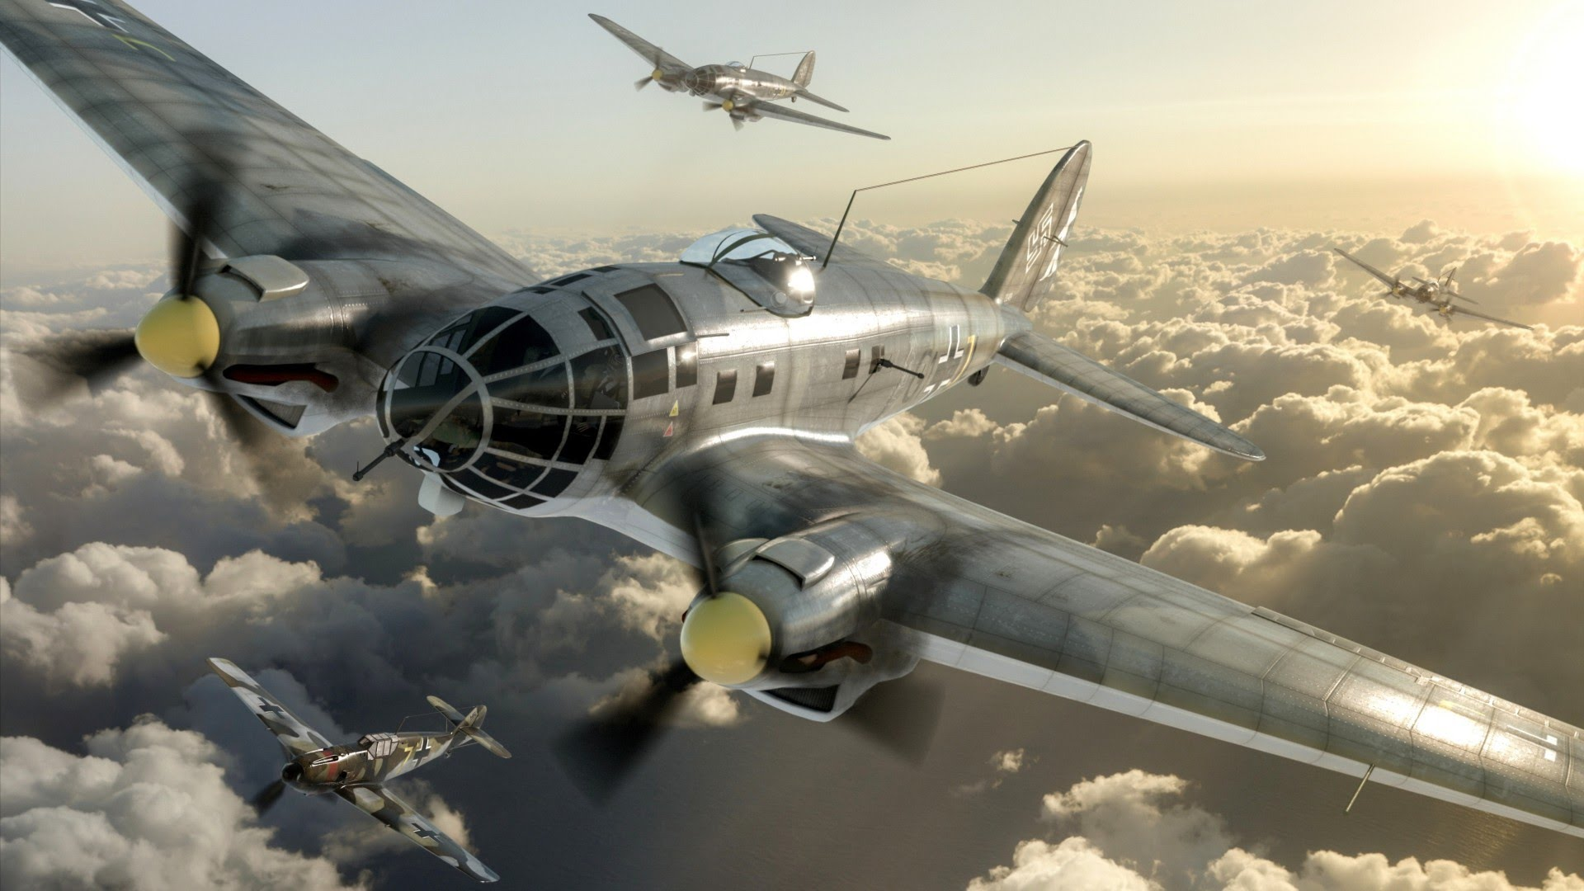
In this Civil war, Germany, Italy and the USSR (Union of Soviet Socialist Republic) sent their armies and weapons to get involved in the fight in Spain. Additionally, Germany and Italy was allied with the Nationalist group owing to the fact that they all believed in the fascist dictator system. Germany and Italy didn’t want Spain to governed by the socialist government. So, they tried to get rid of the Republicans who were socialist from Spain. Whereas, the Soviet Union were in the Republicans side because they supported the socialist. They helped the Republicans because they hated fascist dictatorship. In fact, Germany and Italy supplied the soldiers and arms to the Nationalist, which made them to be more powerful in terms of weapons and military power. Actually, the Germans sent the “Condor Legion”, the well-trained German soldier and the air force group. The Condor Legion was made up of about 19,000 men and the high-tech version of German aircrafts (Namm A., 2003), the German air force groups were called “Luftwaffe”. Also with Italy, they provided 50,000 men and 250 planes (Namm A., 2003). On the Republicans side, the Soviet provided more than 1,000 aircrafts and the pilot to fly them but their aircrafts and weapons were fewer advanced than Germany.

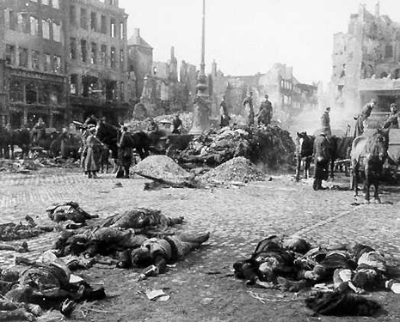
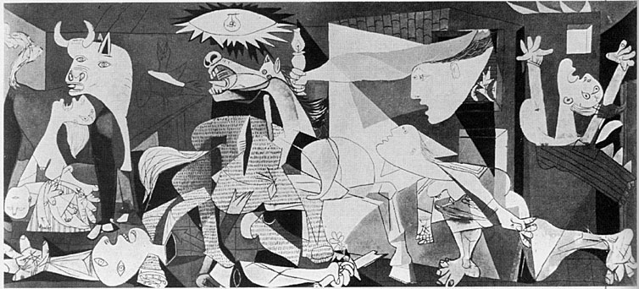
In April 1937, the situation led Germany and Italy used their air force and weapons to bomb people. The Germans used their air force or “Luftwaffe” to bomb people at Guernica, an oil painting about the political statement. They did this on purpose to attack the Republicans. Germany’s air force involvement was so cruel which it threatened the people. Thus, Guernica was destroyed. Many parts of Spain were bombed such as the northern part of Spain, Basque area. The hidden purpose of bombing in Basque was that the Nationalist wanted to demolish Basque race from Spain. So that, they had to bomb the civilians in order to get rid of the Basque nationality. Bombing made Spain in chaos since there were troops, aircraft, and machine gun around many cities. Further, Germany used their air force to launch the bombs and the military to shoot around. They treated people badly by fulfilled the city with bombs. Hence, the situation was too dangerous for people, many people left Spain and many of them died. About 1,700 people were killed, 900 were injured within 3 hours of attacking (Namm A, 2003). Their actions caused Spain lots of damage. In the same time, Italy used their air force to bomb the Soviet’s supply route that they supplied for the Republicans troops so that the Republicans’ supplies were cut. Italy attacked the Soviet due to the fact they believed that attacked the rival’s alliance would escalated their chance of victory.

Apart from Germany, Italy and the Soviet Union, other countries also got involved in this Civil war by the used of non-violation treaty. They got involve after Germany, Italy and the Soviet Union took the actions in Spanish Civil war, which they turned the Civil war into more serious conflict and more Spaniards died because of their involvement. Afterwards, other countries such as Great Britain, France, the US and etc. didn’t want this Civil war to be a serious concerned that would lead to general conflict since Italy started to attack the Soviet. In August 1936, Britain came up with the solution that is the principle of the “non-violation pact”. The non-violation pact had the purpose to avoid the European war and protect the economic depression. Britain knew that if one of these happened, it would affect Europe in a negative way. Due to the afraid of violence and economic collapse, Britain tried to make this principle effective by tried to gain the support from many countries. Part of the non-violation pact was Britain banned of the supplies of arms. To clarify, Britain did this to limit German’s aggression. Further, there were 24 nations signed the principle included Germany, Italy, the Soviet Union and France (Phillips L, n.d.). Whereas, Germany, Italy and the Soviet Union broke the principle, they ignored the treaties they have signed and continued attack the opponent side. At first, France also wanted to support the Republicans side but they were afraid of losing Britain as they main allied. So, this idea had been cancelled. France knew that if they get involved in the Civil war, they would spark the war in Europe. Then, Britain would be angry with France and canceled their alliance. For this reason, France had to accept the non-violation pact to follow Britain. From France’s action, it affected the Republicans chance of winning because they didn’t have France as their main supporter while that escalate the Nationalist chance of winning.

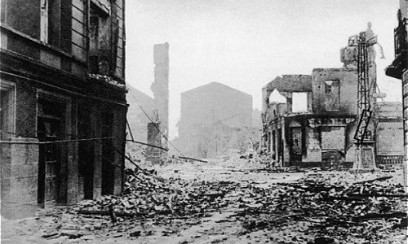
After that, the Republican started to suffer owed to the fact that their military had fell apart. Even though, the republicans currently still gained the supported from the Soviet Union but they couldn’t compete with Franco’s troop that had better soldiers and weapons along with the support from Germany and Italy. When the Republicans army collapsed, they surrendered. As a result, e stronger Nationalist side defeated the republicans. In1939, was the ended of Spanish Civil war. After the Nationalist won the Civil war, they figured out the way restore Spain. Franco imprisoned about 1 million people from the Republicans side and executed about 50,000 people with in 4 years (Namm A, 2003). Finally, Franco became a fascist dictator in Spain from 1939 until he died in 1975.

In conclusion, Spanish Civil war was the very violent civil war in Spain. It involved the alliance countries to bomb and fought against each other, which caused many damage and lost to Spain including the death of innocent people. More than that, the fascist dictator got ruled over Spain and the civilians, which eliminate their freedom away. It was not fair for them that Franco revolted and won the civil war because of the better military and help from the ally countries. According to Thomas Hobbes, everybody had independence to do what he or she wanted (Kemerling G, 2011). From this event, Franco eliminated the Spaniards’ independent away. Finally, the fascist dictator became in power to rule over the country instead of the civilians.

war was not the outbreak that happened in Spain’s history. Even though, there were lots of people died and many parts of Spain were destroyed but it caused Spain to move away from unbearable situation. That was, it led people and the Nationalist group to revolt due to many issues in Spain. However, this event shifted Spain to face enormous changes. In this event, it was right that Franco revolted and brought enormous changed to Spain. It was the beginning to shape Spain to the way it was today.

References:

Orwell, G. (1943). Looking back on the Spanish War. Retrieved from http://orwell.ru/library/essays/Spanish_War/english/esw_1

SPANISH CIVIL WAR. (n.d.).

Namm, A. (2003, October 31). The Spanish Civil War: An Analysis.

Phillips, L. S. (n.d.). BRITISH NON-INTERVENTION IN THE SPANISH CIVIL WAR. Retrieved from http://www.internationalschooltoulouse.net/ibhistory/spain/phillips_ex_essay.htm

Francisco Franco. (n.d.). Retrieved from http://www.history.com/topics/francisco-franco

History.com Staff. (2006). THE GREAT DEPRESSION. Retrieved 2016, from http://www.history.com/topics/great-depression

Kemerling, G. (2011). Hobbes's Leviathan. Retrieved from http://www.philosophypages.com/hy/3x.htm

