Flight bkk (Don mueng airport)to Singapore on Tuesday 23 Dec cost 2,205 thb
Departure 6.25am to 9.40 am

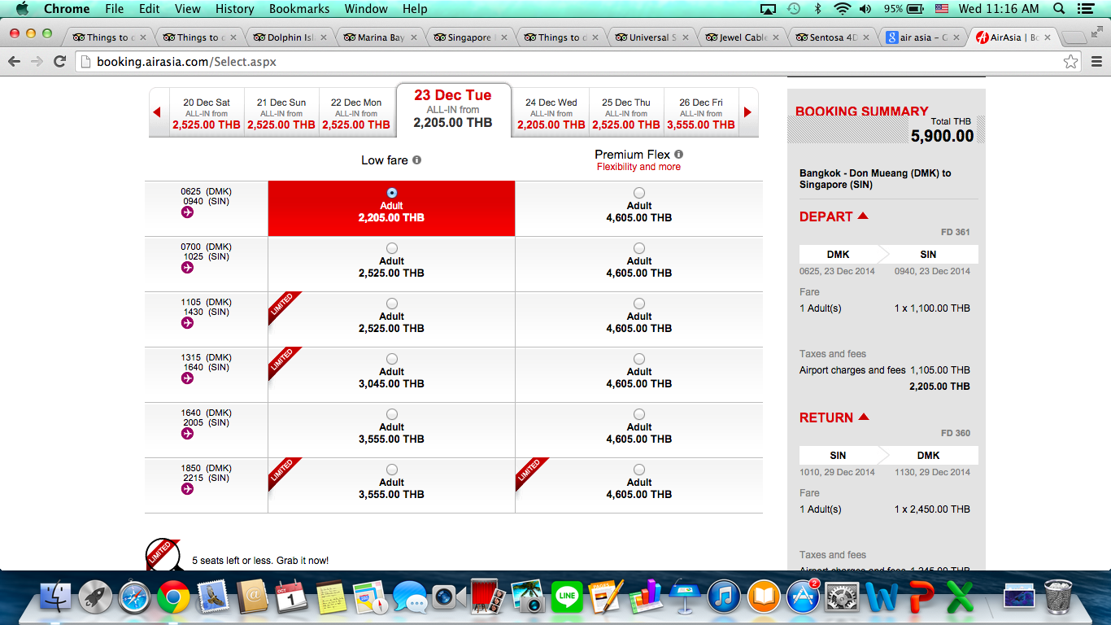

Flight from Singapore airport to bkk(Don mueng airport) on Tuesday 30 Dec cost 3,185 thb
Departure 5.10pm – 6.45pm

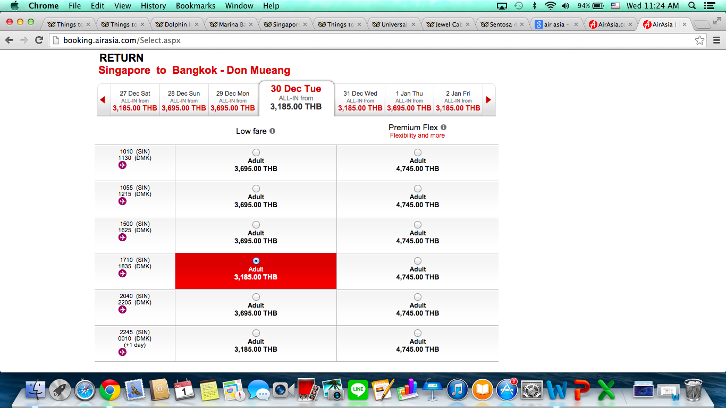

Total cost = 2,205 + 3,185 thb = 5,390 thb

Underwaterworld cost child 20.60 singapore dollar adult 29.90 singapore dollar = child 525.96 thb adult 763.41 thb

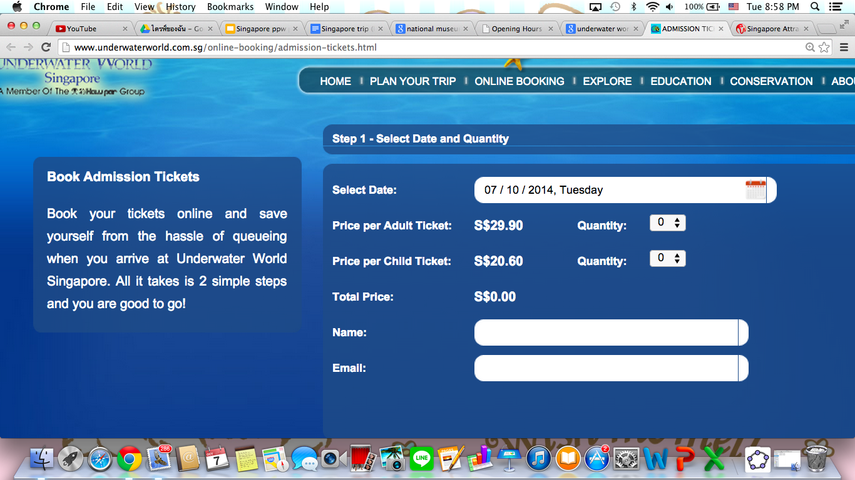

Universal Studio at Sentosa cost 68 singapore dollars = 1736.18thb

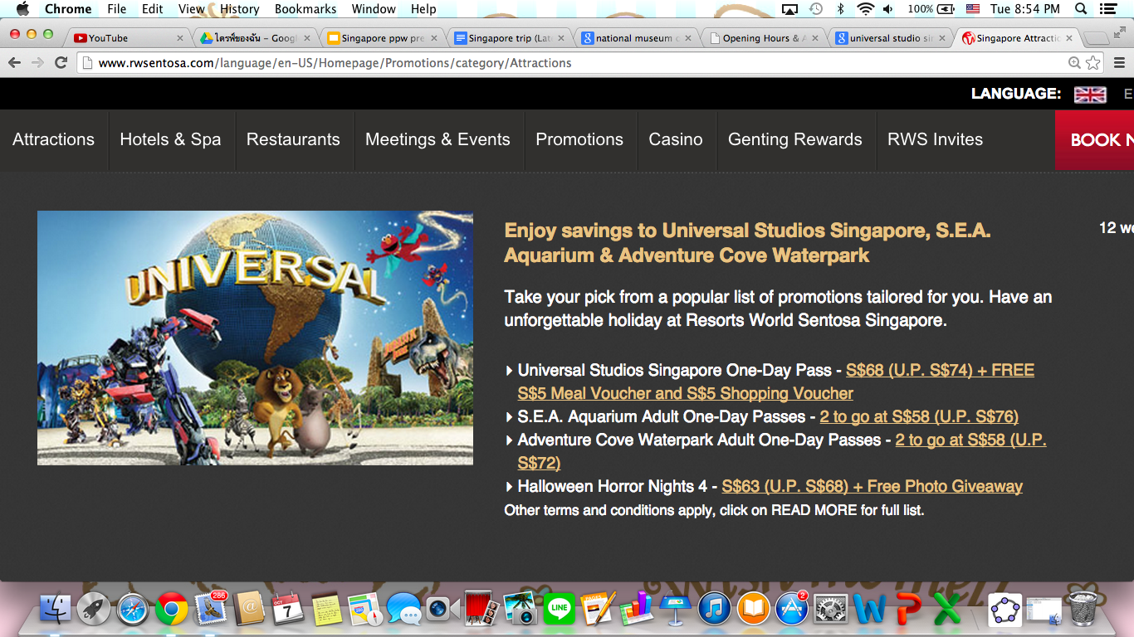

City Gallery cost Free
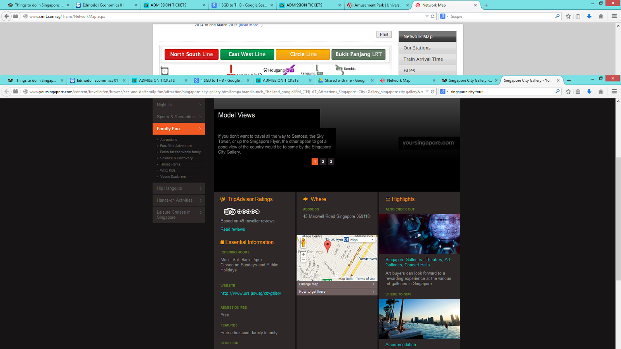

National Museum Cost Student 3 singapore dollar adult 6 singapore dollar = 153.19thb

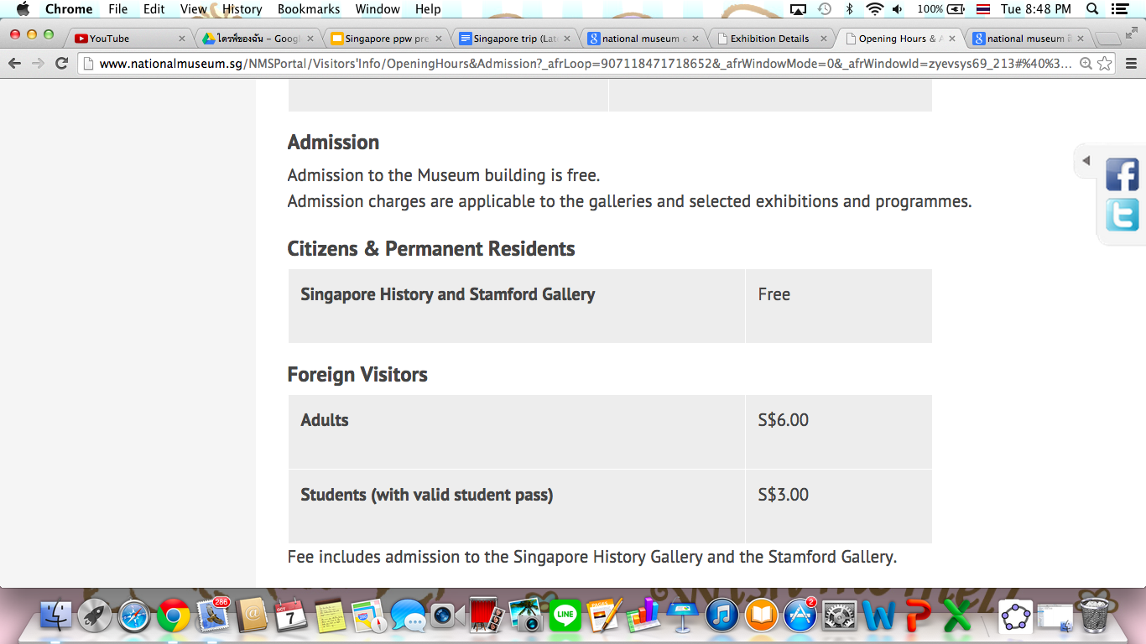

MRT cost
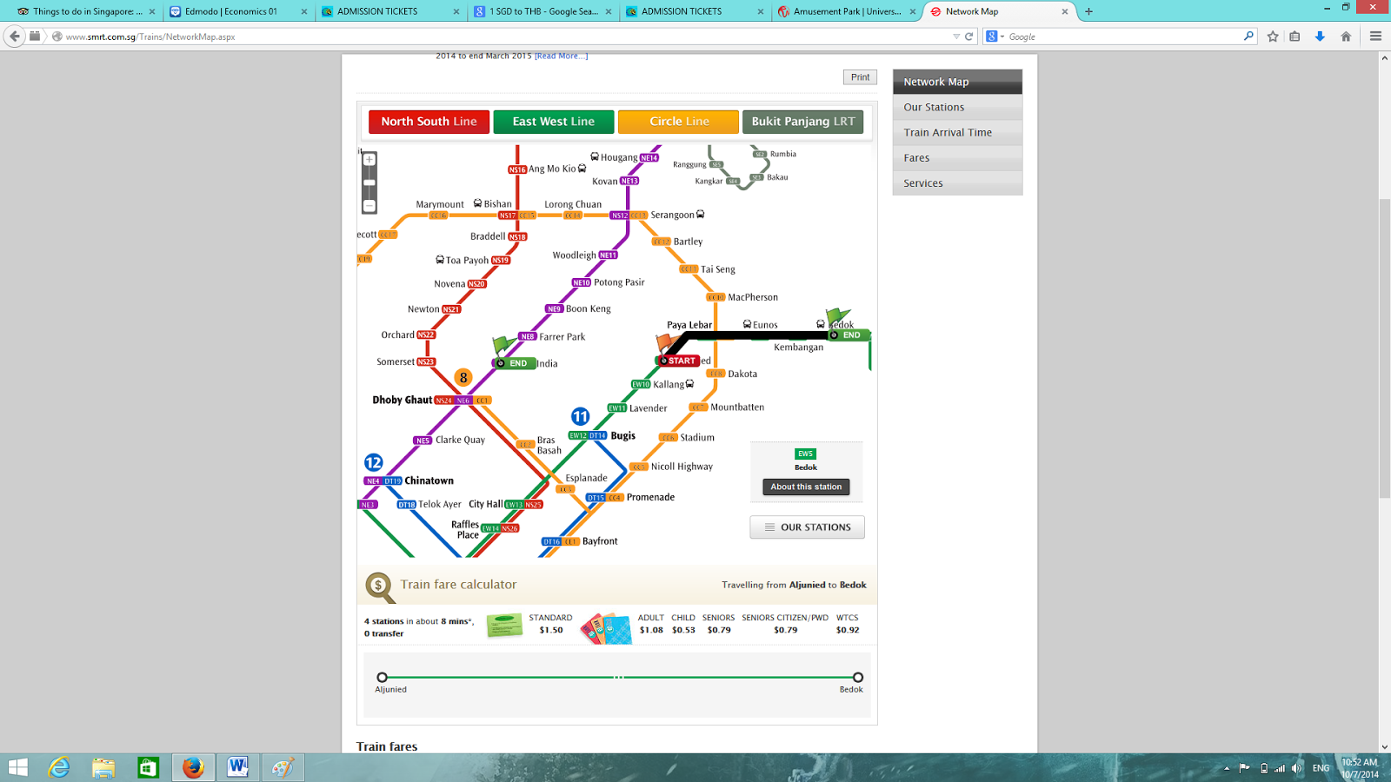

Science centre cost 8dollars = 204.26 thb

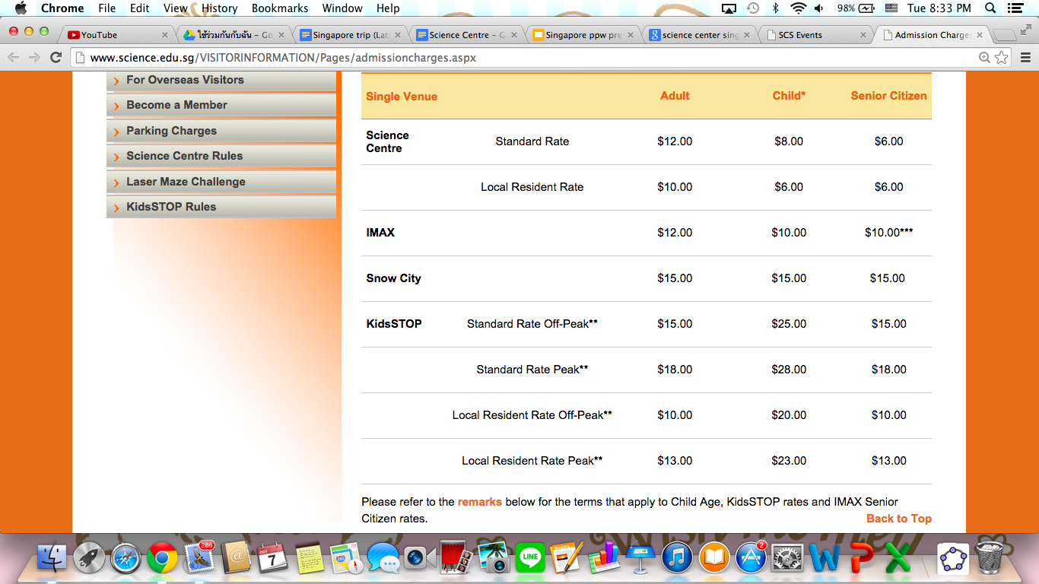

Singapore zoo ticket cost child 18 dollars adult 28 dollars = child 587.16 thb adult 913.36
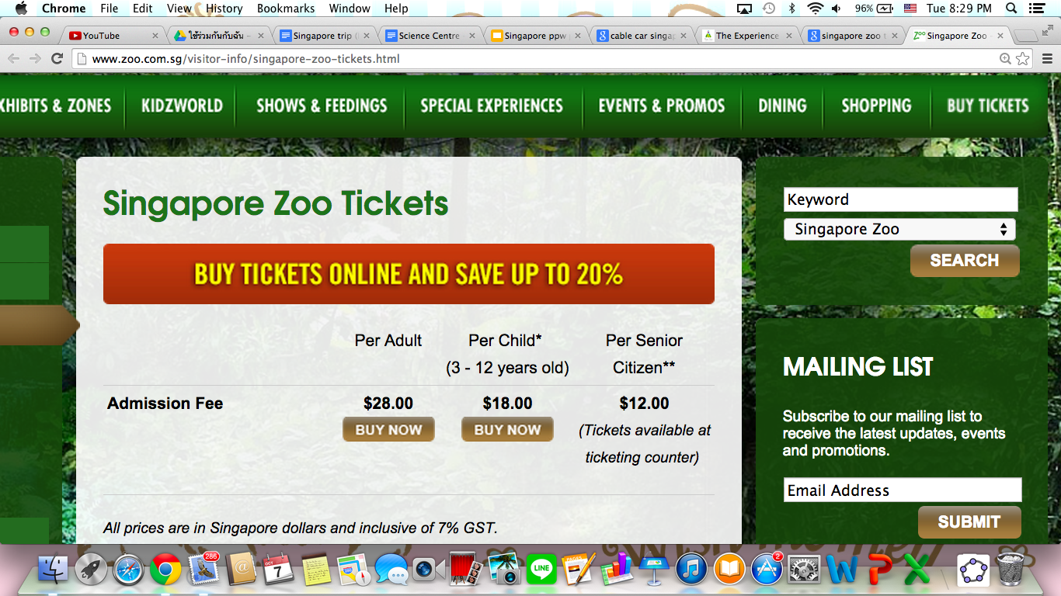

The bus(with a guide) can contain up to 38 people. 28,000/38 = 737thb

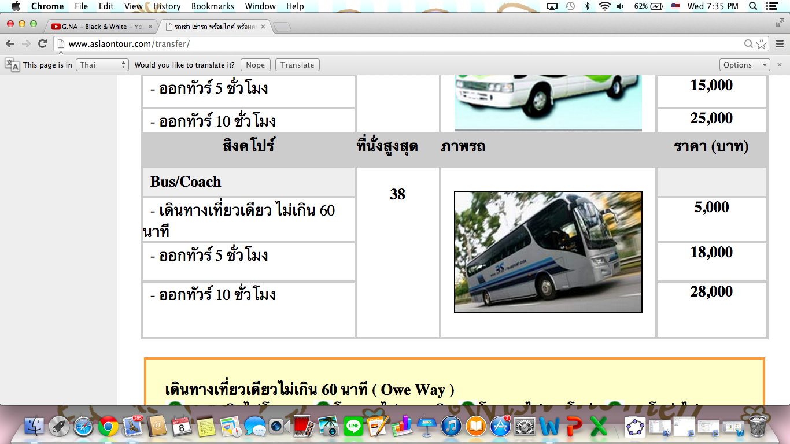

The hotel cost 1,912 thb per night. One room per two people. 1,912/2= 956 thb
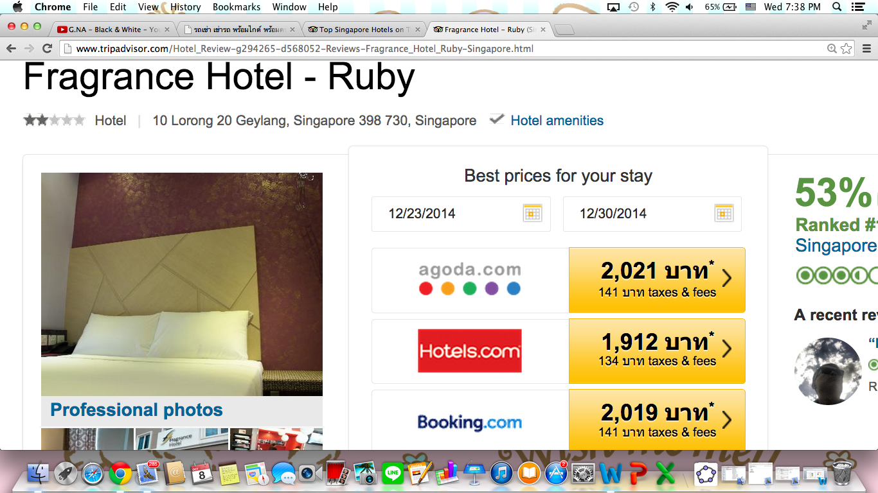

Schedule Price Total price

Tue 23 Dec. (Arrival Day)
6.25-9.40am Flight | 2,205thb | 2,205thb
9.40 Arriving at the airport
10.00-10.30 Take the bus to the hotel | 737*7thb | 7364thb
10.35 Check-in at the hotel | 956*7thb | 14,056thb
11.00-11.50 Relax at the hotel
12.00 Have a lunch
13.30-15.00 Relax at the hotel
18.00-19.30 Have a dinner at
20.00 Have a meeting for tomorrow’s plan
21.00 Go to sleep

Wed 24 Dec. 1st day
7.00-8.30 Have a breakfast
8.30-12.00 Take the bus and have City tour
12.00-12.45 Take the bus to the restaurant
12.45-13.30 Have a lunch
13.45-16.00 Take the bus out to study history at national museum | 153thb | 14,209thb
16.00-16.45 Take the bus back to the hotel
16.45 Arrive at the hotel
16.50-17.50 Relax at the hotel
18.00-19.30 Have a dinner
20.00 Have a meeting for tomorrow’s plan
21.00 Go to sleep

Thu 25 Dec. 2nd day
7.00-8.30 Have a breakfast
8.30-11.30 Take the bus to study science at the science center | 204thb | 14,413thb
11.30-12.15 Take the bus back to the restaurant
12.15-13.30 have lunch
13.30-14.30 free time at the hotel
14.30 Take the bus to China town
15.00 Arrive at China town
15.30-17.30 Go shopping at China town
17.30-19.00 Have a dinner at China town
19.00 Take the bus back to the hotel
19.45 Arrive at the hotel
20.00 Have a meeting for tomorrow’s plan
21.00 Go to sleep

Fri 26 Dec. 3rd day
7.00-8.30 Have breakfast
8.30-9.15 Take a bus to the Sri Mariamman Temple
9.15-11.30 Study humanities at the Sri Mariamman Temple | Free | Free
11.30-12.15 Take a bus back to the restaurant
12.15-13.30 Have a lunch
13.30-14.15 Take a bus to the Sigapore city gallery | Free | Free
14.15-16.00 Take a walk at the city gallery
16.00-16.45 Take a bus back to the hotel
16.45-17.30 Relax at the hotel
17.30 Have dinner
19.00 Have a meeting for tomorrow’s plan
21.00 Go to sleep

Sat 27 Dec. 4th day
7.00-8.30 Have breakfast
8.30-9.15 Take a bus to the Under water world | Child 526 thb, Adult 763 thb | 14,939thb
9.15-11.30 Study biology at the Under water world
11.30-12.15 Take a bus to the restaurant
12.15-14.00 Have lunch
14.00-14.45 Take a bus to the Singapre zoo | Child 587 thb, Adult 913 thb | 15,526thb
14.45-16.30 Visit the Singapore zoo
16.30-17.15 Take a bus back to the restaurant
17.15-19.30 Have dinner
20.00 Have a meeting for tomorrow’s plan
21.00 go to sleep

Sun 28 Dec. 5th day
7.00-8.30 Have a breakfast
8.30-9.15 Take the bus to Marina Bay
9.45 - 15.00 Free time on Marina bay | Free | Free
15.30-16.30 Take the bus to the restaurant
17.45-19.45 Have a dinner
20.00 Have a meeting for tomorrow’s plan
21.00 Go to sleep

Mon 29 Dec. 6th day
7.00-8.30 have breakfast
8.40-10.00 Take the bus to Sentosa
11.30 Get to Universal Studio | 1736thb | 17,262thb
11.40 Buy Ticket
12.30-13.30 Eat Lunch
15.30 Everyone meet at the front of the universal studio
16.00 Back to the hotel

Tue 30 Dec. Departure day
7.00-9.00 Have breakfast
9.00-11.00 Free time at the hotel
11.00-12.30 Have lunch
12.30-13.00 check-out from the hotel
13.00-15.00 shopping in the Orchard Road
15.00-15.30 Take a bus to the airport
15.30 Check-in at the airport | 3,185thb | 20,447thb

