Osmosis lab report
By
Ning> Jitrawan Jaroensintaweekul #2
Prim> Patsatorn Yordchaiyapruk #22
Mudmee> Smita Jirayingcharoen #3
Po> Sarin Termteerakij #20
Owen> Tanadech Santipiyakun #14

Introduction: Water is an important part for life. All organisms could not survive without it because of its functions takes the important role of the whole body and within the cell. Furthermore, it is very interesting to study how it moves in and out of the smallest unit of life which we called it ‘the cell’. In the cell, water pass through the membrane by osmosis. Osmosis is the process which water pass through the cell from high concentration of water to low concentration of water to make the concentration equal called isotonic. Hypotonic is when the concentration of soolute outside the cell is less than inside the cell. Hypertonic is when the concentration gradient of solute outside the cell is greater than inside the cell. In this experiment, we test how water osmosis through the cell with the potato by putting it in the different concentration of water.

Purpose: The purpose of the laboratory experiment is to study osmosis and tonicity by observing pieces of potato, which are put into distilled water.

Hypothesis:
1.If a piece of potato is put into distilled water, then that piece of potato will be bigger.

2.If a piece of potato is put into salt water, then that piece of potato will shrink.
Material List :
2 Beakers
Electronic Balance
RulerGroups bring their own ruler
Distilled water
Concentrated salt water
2 Potatoes
Calculatorgroups bring their own calculator Weighing paper
Gloves
Lab Coat
Goggles

Procedure :
Day 1>
- 1. Collect materials for your group

- 2. Use your ruler to find the height, length, and width of each Potato
- 3. Calculate the volume of your Potato (LxWxH)

- 4. Use the electronic balance to find the mass of your Potato. Remember to lay down a piece of weighing paper and set to zero.

5. Record descriptive observations in your notebook about the Potato prior to the experiment.

6. Fill your beaker half way with distilled water. Put one of your Potato into the beaker. Set the beaker aside for one day.

7. Fill your 2nd beaker with concentrated salt solution half way. Put your 2nd gummy bear into that beaker. Set beaker aside for one day

- Day 2 >
1. Collect groups beakers with gummy bears.

2. Carefully remove the gummy bears from the beakers.

- 3. Repeat steps 2-5 from Day 1

- 4. Calculate the percent change in the size of each gummy bear.
  - ~Percent change in height (Height after- Height before/ Height before x 100% = ?)
~Percent change in width
  - ~ Percent change in length
  - ~ Percent change in volume
  - ~ Percent change in mass

Data Tables :

Data Table A for Potato volume
 | Potato1 |  | Potato2
Dimensions | Initial: Before soaking | Final: Afiter soaking in distilled water | Initial: Before soaking | Final: Afiter soaking in salt water
length (cm) | 2cm | 2.3cm | 2.1cm | 1.8cm
Width (cm) | 1.8cm | 1.9cm | 2cm | 1.6cm
Height (cm) | 1.5cm | 1.6cm | 1.9cm | 1.4cm
Volume(cm3) | 5.4cm3 | 6.9cm3 | 7.98cm3 | 4cm3

Data table B for Potato descriptions
Potato1(water) | Potato2(salt)
Descriptive observations before soaking in distilled water:  cude, yellow, smooth | Descriptive observations before soaking in salt water:  cude, yellow, smooth
Descriptive observations after soaking in distilled water:  Stay the same color, it got bigger | Descriptive observations after soaking in salt water:  Change color, It got smaller

Data Table C for Potato mass
 | Potato1(water) |  | Potato2(salt)
Mass in grams | Intial: Before soaking | Final: After soaking in distilled water | Intial: Before soaking | Final: After soaking in salt water
Potato mass(g) | 6.25g | 7.6g | 6.6g | 5.5g

Data Table D for percent changes
Potato | Potato1(water) | Potato2(salt)
Percent change in height | +6.67% | -26.32%
Percent change in width | +5.56% | -20%
Percent change in length | +15% | -14.29%
Percent change in volume | +27.78% | -49.87%
Percent change in mass | +21.6% | -16.67%

Bar Graph of Results : 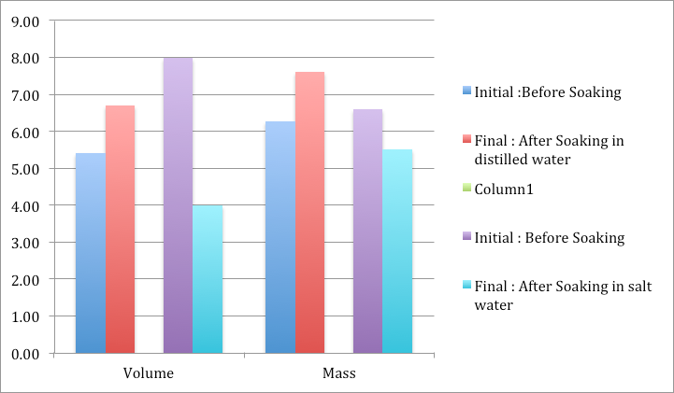

Analyzing Results : 1.What happened to the potato after being soaked in distilled water over night? Be descriptive and detailed in your answer. Use your knowledge of membrane transport.
>> The potato gets bigger and heavier after being soaked in distilled water because of the osmosis of water. The concentration inside the potato is higher than distilled water, so water moves by concentration gradient, into the potato. The water moved inside the potato towards high concentration of solute. As a result, the potato gets bigger because of more water comes inside.

2.What happened to the potato after being soaked in the salt water over night? Why? Be descriptive and detailed in your answer. Use your knowledge of membrane transport.
>>The potato shrinks after being soaked in salt water over night because osmosis. The concentration in salt water is higher than potato, so water in potato move out from potato to salt water, and the potato shrinks because of the water moves out of the potato.

3.Define the terms diffusion, passive transport, active transport, and osmosis. In each of your definitions, describe the role of a concerntration gradient.
>>Diffusion: Diffusion is passive transport, which molecules move down concentration gradient freely through the phospholipids bilayer until equilibrium.
>>Passive transport: Passive transport requires no energy, but requires some types of proteins, such as channel proteins and carrier proteins. It is when molecules move down concentration gradient until equilibrium.
>>Active transport: Active transport requires energy, which is ATP, in order to transport molecules. It is when molecules move up the concentration gradient.
>>Osmosis: Osmosis is a case of diffusion, but focuses on solvent which is water.

4.Water moves toward low water concentration area which is an area that is high iranes are said to be selectively permeable (or semi-permeable). What does this term mean, and how does this affect the way that molecules are able to move through cellular membrane
>>Because it allows only the specific molecules to pass through selectively permeable membrane for the cell’s function. This affect the way molecules to be more difficult to move inside the plasma membrane.

5.Which type of molucule is more likely to quickly pass through a celluar membrane via simple diffusion. polar or nonpolar? Why? Non-polar molecules is more likely to quickly pass through a cellular membrane because polar molecules are bigger than non-polar molecules.

Conclusion :
From this experiment, it helps us learn more about osmosis, and how the water move due to the concentration of the solvent. In the experiment, we don’t have any errors in the process. The experiment clearly shows how water osmosis through the membrane.

