Mumps Viruses
Mumps is a viral infection transmitted by and affecting only humans. While the salivary glands (especially the parotid gland) are well known to be involved during a mumps infection, many other organ systems may also experience effects of the virus infection.

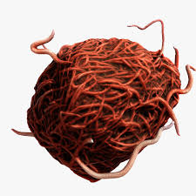
Defenses

Vaccine

The MMR vaccine provides 80% effective immunity against mumps following a two-dosage schedule (12-15 months with booster at 4-6 years of age).
Behavioral
Get the veccine
Treatment
There is no direct treatment for mumps. Supportive care may be provided, including efforts to lower fever.

Offenses

Attacks
The virus is spread by respiratory droplets. These can become airborne when an infected person coughs, sneezes, and talks. Additionally, a person can contract the virus by touching surfaces that are contaminated with infected droplets.

Outcome
The initial symptoms of mumps infection are nonspecific low-grade fever, malaise, headache, muscle aches, and loss of appetite.

Incubation Duration
14-18 days 10 days

|
|
|
|
|
|
|
|
|
|
|
|
|
|
|
|
|
|
|
|

