Restaurant

Finding something to eat for a special moment with friends and family? This restaurant will answer your question.

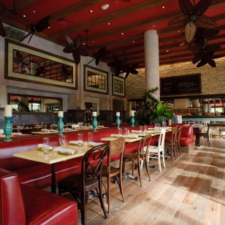
The atmosphere in the restaurant

‘Sugarcane Raw Bar and Grill restaurant’ is located in the heart of Miami’s emerging Midtown and district 3252NE first avenue. We’re highly recommended for Italian food lovers. If you are Italian food lovers we are pretty sure that this restaurant will be your great choice. Especially, when you are finding a restaurant with a beautiful atmosphere. This restaurant will give you a unique and delicious flavor of food.

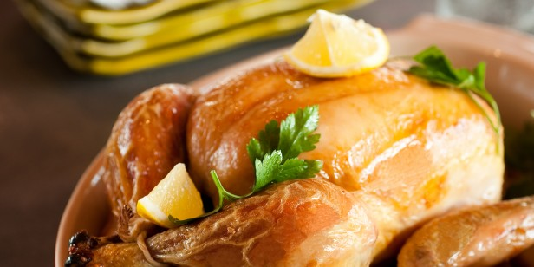
Grilled chicken

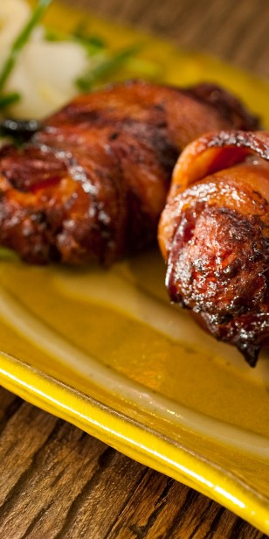
Wrapped bacon with fried chicken

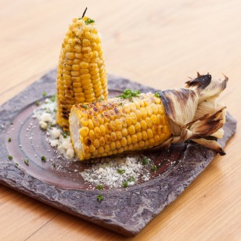
Grilled corn with butter and salt

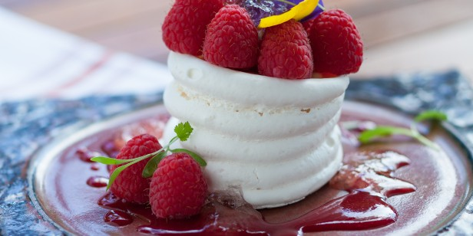
Raspberry cake

