Biology 10-01

Organic molecules

Date of experiment: 6/11/14

Members:
BB Pattraporn Kheerinpharadorn
Mew Kavitsara Panichumnuaysuk
Pang Samitra Ngenpisutsin
Japan Jiratchaya Sakulboonthanom
Prim Patsatorn Yordchaiyapruk

Introduction:
In our body, organic molecules are the small molecule in our body. Although, it is small but we cannot function the body without it. So, it is an important part to make out life. Organic molecules are living molecules which always contains carbon and hydrogen. In class, we studied Carbohydrates, Lipids, Proteins and Fats. The single unit of molecules are called Monomers and when many monomers are joining together they made up polymers. They link to each other by dehydration reaction which it happens when the water molecule is released.

Purpose:
Our purpose on this experiment is to study about the organic molecules contain in each solution. We use the four reagents. Each reagent react with a different organic molecules. So, we can know that what organic molecules are in this solution and how they react with those reagents.

Hypothesis:
“If the sample reacts with Iodine Solution, then it contains monosaccharide. The solution would turn from yellow to black depending on the concentration of starch in the sample.”
“If the sample reacts with Benedict Solution, then it contains monosaccharide. The solution would turn from blue to green, yellow, orange and red depending on the concentration of sugar in the sample.”
“If the sample reacts with Biuret Solution, then it contains monosaccharide. The solution would turn from blue to purple depending on the concentration of protein in the sample.”
“If the sample reacts with Absolute Ethanol, then it contains monosaccharide. The solution would turn from yellow to cloudy yellow depending on the concentration of lipids in the sample.”

Materials:
- Google
- Gloves
- Lab cloth
- Beaker
- Test tube
- Benedict’s solution
- Iodine’s solution
- Biuret’s solution
- Glucose solution (Monosaccharides)
- Starch solution (Polysaccharides)
- Gelatin solution (Protein)
- 3 Unknown’s solution
- Water

Procedures (Carbohydrates and proteins):
1) Fill 300ml of water into the 500ml beaker with a magnetic stirrer. Place the beaker on the hot plate. (DO NOT TURN ON THE HOTPLATE UNTIL TOLD)
2) Ask an instructor or a lab technician to show you how to use a hot plate. Turn on the hot plate and the stirrer to the instructed levels.
3) Make labels (using the abbreviations in the Table 4) on provided marking tape to be placed on the outside of each test tube. This is done so you do not forget which test tube contains what sample. Use the chart below for abbreviation.
4) Apply the label on each test tube. And arrange the test tube on the rack according the Table 4.
5) Put on protective gloves and a goggle (for members who will be dealing with chemicals).
6) Adding approximately 1cm. of each sample according to the label. Do NOT forget to arrange the test tube according to the chart.
6.1 In total you should have 3 tubes of each of the following samples
6.1.1 Water negative controls
6.1.2 Glucose solution (Monosaccharide) positive controls for Benedict’s solution
6.1.3 Starch solution (Polysaccharide) positive controls for Iodine solution
6.1.4 Gelatin solution (Protein) positive controls for Biuret solution
6.1.5 Unknown 1
6.1.6 Unknown 2
6.1.7 Unknown 3
7) In ROW1: Add 5 drops of Biuret solution into each of the sample.
7.1 Gently swirl the test tube around so that the solution is evenly spread out in the test tube.
7.2 Observe and take note any the color changes in the result section.
8) In ROW2: Add 5 drops of Iodine solution into each of the sample.
8.1 Gently swirl the test tube around so that the solution is evenly spread out in the test tube.
8.2 Observe and take note any the color changes in the result section.
9) In ROW3: Add 5 drops of Benedict’s solution into each of the sample.
9.1 Gently swirl the test tube around so that the solution is evenly spread out in the test tube.
9.2 Use the beaker tong to transfer the test tube ONE AT A TIME into the boiling water in the beaker for around 3-5 minutes.
9.3 Observe and take note any the color changes in the result section.
10) Turn of the hot plate and stirrer. Be careful not to touch the hot plate as it will remain hot for a long time.
11) Once you have finished the experiment, please help remove the marking tape on the test tubes.
12) Continue to the next part of the experiment.

Procedures (Oils):
1) Collect two test tubes labeled A&B from your instructor.
2) Unscrew the cap of the tube
3) Add approximately the same amount of absolute ethanol into each tube.
**CAUTION: Absolute ethanol in highly flammable, DO NOT POUR absolute ethanol NEAR THE HOT PLATE.
4) Screw the cap back on tightly.
5) Shake each tube vigorously. Observe the change and record the findings in the results section.
6) Call your instructor to show you the brown-paper test and record the findings in the results section.

Result of the experiments:
 |  |  |  | Content
 |  |  | Water | Glucose Solution | Starch Solution | Gelatin Solution | Unknown1 | Unknown  2 | Unknown3
Testing |  | Abbreviaton | W | GL | ST | GE | U1 | U2 | U3
Reagents | Row 1 | Benedict’s Solution | Blue | Orange | Blue | Purple | Yellow | Blue | Yellow
 | Row 2 | Iodine Solution | Yellow | Yellow | Black | Yellow | Yellow-black | Black | Yellow
 | Row 3 | Biuret Solution | Light Blue | Light Blue | Cloudy Blue | Purple | Yellow | Cloudy Blue | Purple

 | Emulsification Test
Tube | With Ethanol | Without Ethanol
A | Clear | Plain water,Clear
B | Cloudy Yellowish liquid | Yellow,Separate layer

Analyzing results Questions:
- Does rice store glucose as starch? How do you know from your results?
Answer Yes, it does because the iodine solution change from blue to black.

- Do onions store glucose as starch? How do you know from your results?
Answer Yes, it does because the iodine solution react with onion. The solution changed to become black.

- What sugar is most likely present in diluted yoghurt?
Answer Lactose is most likely present in diluted yoghurt.

- A test tube contains starch, a digestive enzyme for starch, and water. The Biuret test is negative showing no change. However, after 30 minutes, the Benedicts test is positive. What substance is present? How do you know?
Answer The enzyme use the water to break the polymer. As a result, sugar is present. Benedict solution reacts with sugar. The color of the solution change. So, in starch it contains sugar.

- Explain how you would test an unknown solution for each of the following:
- Sugars - use the benedict solution. To have positive result the solution must change from blue to orange.
- Fats - use the Absolute ethanol. To have positive result the solution must change from clear water to yellow and it separate layer.
- Starch - use the Iodine solution. To have positive result the solution must change from yellow to black.
- Proteins - use the Biuret solution. To have positive result the solution must change from blue to purple.

Conclusion:
From the result that are show, we can know what is our positive and negative controls. Positive control will react with the solution but negative control will stay the same. In this experiment, water is the negative control. The positive control are Glucose solution, Starch solution , Gelatin solution and Lipid. Glucose solution is the positive control for Benedict solution because it changes from blue to orange. Starch solution is the positive control for Iodine solution, it changes from yellow to black. Gelatin solution is the positive control for Biuret solution because it changes from blue to purple. And lipid are the positive control for Absolute Ethanol because it changes from clear solution to cloudy yellowish solution. Unknown1 is positive with Benedict solution because it changes from blue to yellowish liquid.Unknown2 is positive with Iodine solution because it changes from is yellow to black. Unknown3 is positive with Biuret solution because it changes from blue to purple. And also with Benedict solution because it also changes from blue to yellow.

Pictures:
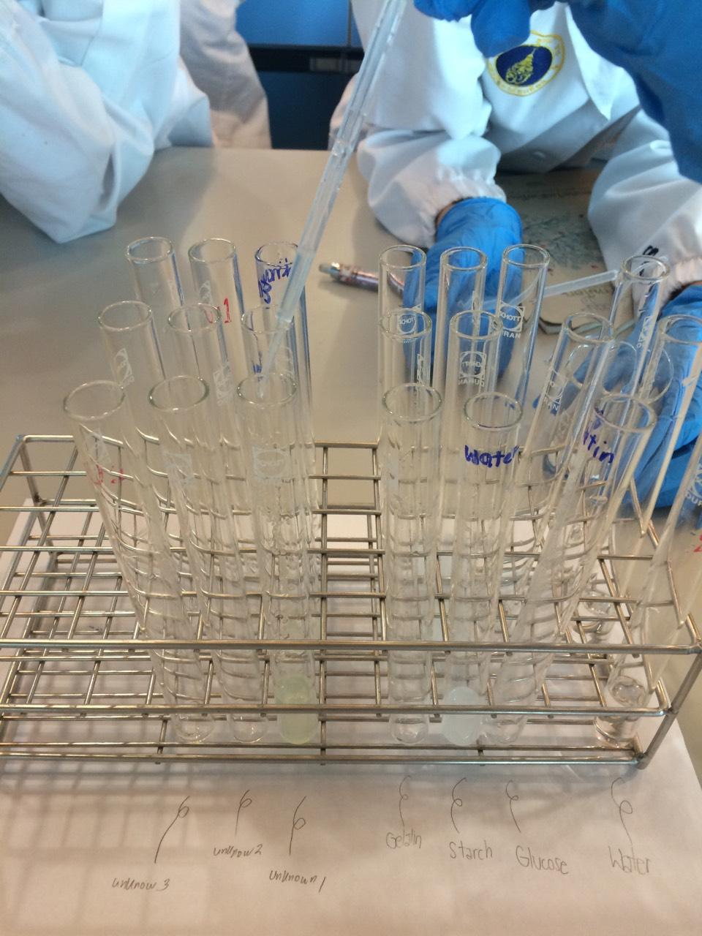

In this picture is when we label all 9 solutions (Water, Glucose, Starch, Gelatin, Unknown 1 , Unknown 2, and Unknown 3).

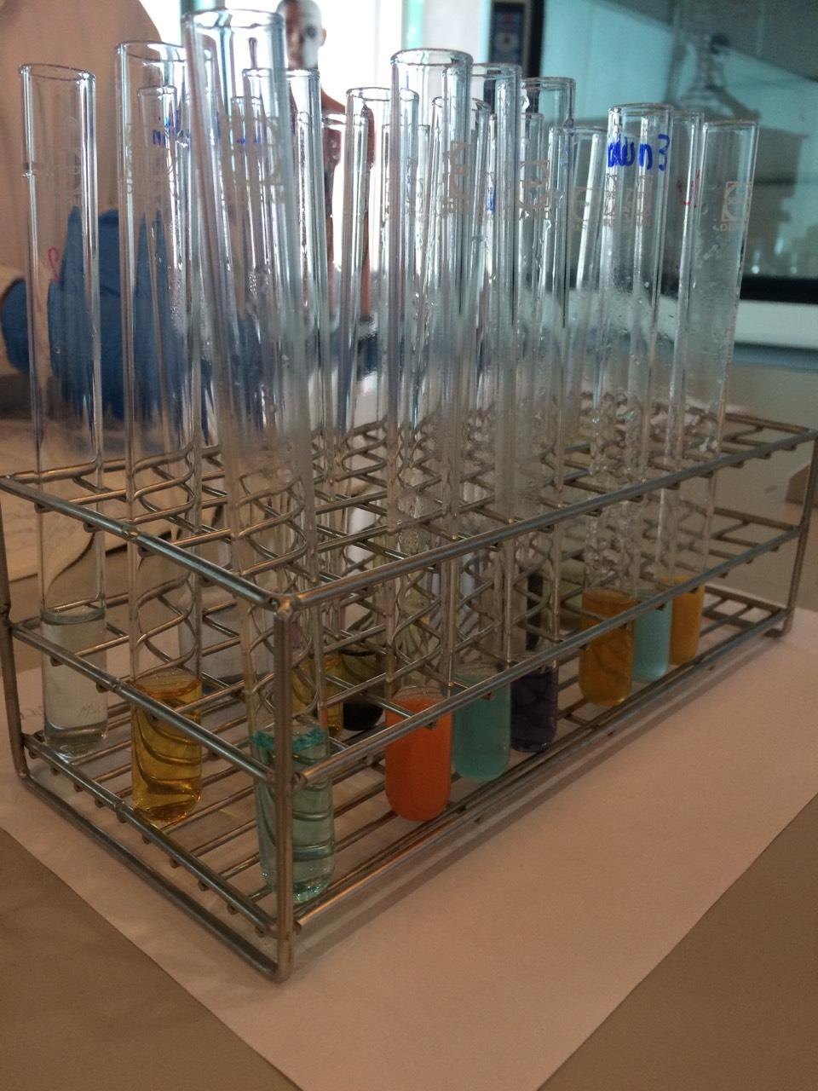
In this picture we took after we put all the solution that we wanted test into all 9 solutions that we had (according to first picture). This picture show the change of color in some solution (positive controls) but some are not change color (negative solution).

Other pictures:

