Unit 2 Nutrition: Lesson 2, Understanding Food Labels
Type of Work: Pair Product: Doc Class Time: 1 Period EOC: Embedded Doc
Teacher: Ms. Sarina Promthong Due: Within the period
NAMES: Prim, Mew Class, Group: 10-01 My LEVEL: 3
Directions: Grab an item at at home or grocery store. Try to get an item that you may typically eat. Try not to get a drink or supplement as these won’t work for this activity.
Answer the following questions in order stopping based on your level attempted. Embed Google Doc into ePortfolio when Done
What is Your FOOD LABEL/PRODUCT:
1. What is a serving (Number of ounces, number of chips etc.,) ? 50g.
2. How many total servings are in your product? (If you were to eat the whole package how many servings would you have had)? 2 servings.
3. How many servings do you think you would have if you had this product? I think I would have 2 servings.
4. How many calories are in one serving? 140 cal. Is this high or low for what you are eating? I think it has a moderate calories Why? Because if we compare to the quantity of food and its calorie. I think it’s not so much.
5. Do think this product is good for you? Why? I thinks the product is not good for me because it contains lots of sugar and fats.
6. What is the % DV of Vitamin A 0% C 0% Calcium 0% Iron less than 2% in your product?
7. How many total calories are from fat? 50 What % of DV of fat? 9%
8. How many grams of total carbohydrates: 20g. What is the %DV Carbs: 7%
9. What 2 items have a Low % DV ( <5%)? What 2 items have a HIGH % DV? (>20%)
Low= Vitamin A, Vitamin C High= It doesn’t have any high% DV
10. What % of the calories from one serving are from fat? (HINT: Divide total calories from fat by total calories from product): 28%
11. Are there any sugars in the ingredients listing (Name all)? Sugar
12. So would your product be classified as nutrient dense, empty calories or neither? _____
Explain why: I think it’s neither because this product is not nutrient dense and empty in calories.
Think of a healthier alternative for this product  Eat just a few pieces of it and exercise more.  Snip the label and place it to the right You can shrink it down. | Place Label Below Here  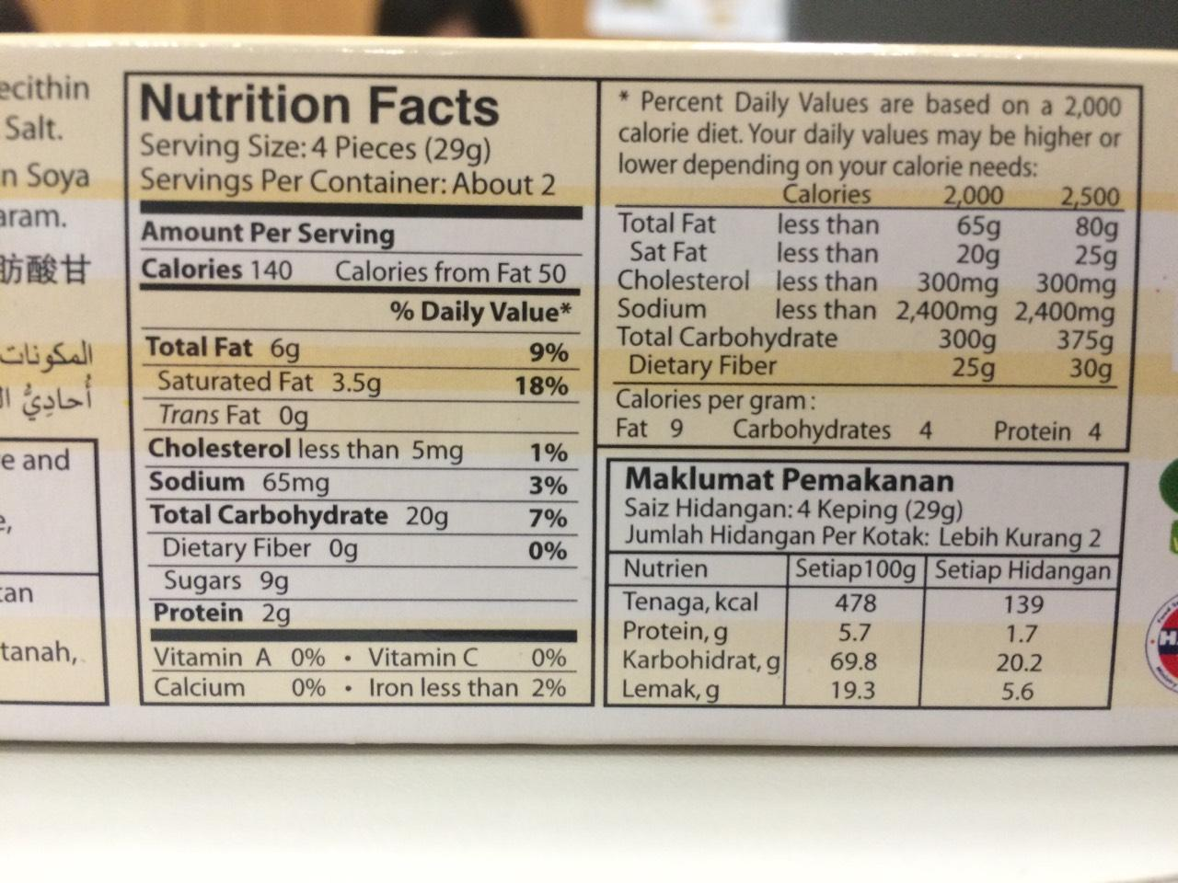 | Describe the product and why it is healthier.  My product is butter waffles. It contains high carb, sugars, fats so,I suggest to eat just a few pieces.

