**Health Science Grade 10: Unit 2, Lesson 1 Nutrients  
Type of Work**: Teams/Group  **Product:** Class notes & MindMap **Class Time:** 1 Period

**Teacher:** Ms. Sarina Promthong **Due:** 1 Day Class of Note-Taking/ 1 Day of MindMapping

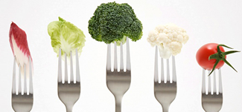

**Concept:** The function of eating is not just to meet our hunger needs. We often fail to realize that food acts as our fuels. This fuel is enriched with vital nutrients; and every one of these nutrients has a specialized purpose to fulfill for our nourishment needs. Nutrients are these nourishing substances that we obtain from food that are vital for growth and maintenance of a healthy body throughout life. There are 6 classes of nutrients found in food and are all essential for regulating a wide array of bodily functions.

**Goal:** Identify the six main classes of nutrients and provide an overview of each nutrient (functions, quality food sources, etc). Each nutrient will have nutrient-specific content as well (complex vs. simple carbs, sat. vs. unsat fats, etc).

|  |  |  |  |  |  |  |
| --- | --- | --- | --- | --- | --- | --- |
|  | **Content and Learning Targets (Resources Linked)** | **Learning  Targets** | **Originality and Creativity** | **Maximation of Media Type** | **Collaborative  and  Cohesive** | **Use of Time  Group &  Participation** |
| 1 | **Provide -Definition/Overview   of each Nutrient -Identify Quality Food   Sources High in   Nutrient** | **Details missing or inaccurate. No understanding demonstrated as all information was cut/paste.** | Expresses no creativity and/or original thought on behalf of the student. | No Media Used. incorporated any media into their presentation. | The Mindmap structure was different for each student. | Group did not use time wisely ,did not split task equally or fairly.  People stopped when ‘their’ part was done. |
| 2 | **Provide the Major Functions of Each Nutrient** | **Limited research; limited understanding of learning targets based on inaccuracy or straight cut/pasting.** | Rather plain and shows little to no creativity on behalf of the student(s) | Student (s) have scratched the surface of the media/tech method | Mindmap structure and organization prevented a clear understanding of content. | Multiple times where group was off task and it was clear group work was not delegated. People stopped after ‘their job was done.’ |
| 3 | **Provide the Recommended Daily Intake Based on a 2,000 calorie Diet of Each Nutrient** | **Good Research; fairly accurate understanding of learning targets, general information lacking details at points.** | Shows some creativity and is visually appealing. | Students have used all but the most difficult to master forms of the media or technology. | Most of the students MindMap was similiar in the targeted structure and layout . | Group was productive but had periods of time where they were off task or not working together. |
| 4  5 | **Provide Nutrient Specific Information for Each Nutrient**  **LEVEL 5/X-Tra Credit Question Available for Each Nutrient!!!!** | **Comprehensive Research; clear and accurate understanding of learning targets; detailed and thorough** | Unique and attractive while representing the student’s original thoughts and creativity. | Student(s) have mastered the media/tech method and maximized it’s use for this project. | It was clear that the entire group worked to form a cohesive (similar format and layout) mindmap that was easy to follow from one topic to another. | Group was productive and on task the entire time. All group members worked together to complete product. |

**Level 5 Programs to Try:** [**Popplet**](http://popplet.com/) [**Memofon**](https://www.memofon.com/) [**WiseMapping**](http://www.wisemapping.com/) [**Spiderscribe**](http://www.spiderscribe.net/) [**Coggle**](https://coggle.it/)

**Directions:**  1. You will **work in groups of 4**, Decide your group.   
 2. **ONE PERSON make a copy of this document** (Click **File**, **Make a copy**, title the docuemnt **Class\_Nutrients,** and **share** to your group members)

3. **Decide who is going to take each class of Nutrients  
 Linked for Content Outline(**[**Carbohydrates**](#id.6aphjj6re9vf)**,** [**Fats**](#id.vgyt0bkwmoa)**,** [**Proteins**](#id.j504ihuetdx3)**,** [**Vitamins, Minerals**](#id.1v74lsbikhfs)**,** [**Water**](#id.6ka5iasmk81q)**)**

4. **Look at the content below** and how it is organized by level and get going on your portion.

**DefinedQuality Food SourcesRecommeded Daily IntakeNutrient Specific Info X- Credit**

5. Before the class ends, **ONE PERSON share** your group file to “[sarina.muids@gmail.com](mailto:sarina.muids@gmail.com)” for progress check, group with most done in class get the most in-class assignment score

6. **Complete the below class notes,** use the **provided resources** to help you complete it before MindMapping next class.

**Resources:** [**Teacher Notes**](https://docs.google.com/presentation/d/1nIElpmz0ZDdOEDsKGdnw6EQtj1MqFKzsowI7TIJ7Yk8/edit?usp=sharing) **Web Resources**  [**1**](http://www.fitnessrepublic.com/nutrition/carbohydrates.html) [**2**](http://www.merckmanuals.com/home/disorders_of_nutrition/overview_of_nutrition/carbohydrates_proteins_and_fats.html) [**3**](http://www.diet.com/g/nutrients) [**4**](http://en.wikipedia.org/wiki/Nutrition#Nutrients)[**5**](http://www.nutrition.gov/whats-food/carbohydrates-proteins-fats-fiber/carbohydrates) [**6**](http://www.nlm.nih.gov/medlineplus/nutrition.html)

**CLASS 10\_01\_\_\_\_\_\_\_\_\_\_\_**

**Overview of Nutrients Name of Persons ( Japan )  
What are Nutrients: subtances in food that give energy, body process,growth and repair body.**

**What are the 6 Classes of Nutrients (list Them): carbohydrates,lipid/fat, protein,vitamins,minerals,water  
What are Macro Nutrients and List Their Calories:carbohydrates, lipid/fat, protien / 4:9:4**

**List the Major Functions of Nutrients  
1.build and repair cell  
2. regulate body processes  
3.provide energy  
4. disease prevention  
What Factors Influence Different Nutritional Requirements:**

**Carbohydrates Name of Persons ( Japan )  
Carbohydrates is an important part of nutrition and it can both healthy and unhealthy food. People need it in large amount for energy.**

**Quality food sources (What types of *healthy* food are high in this nutrient)  
Pictures   
1.** 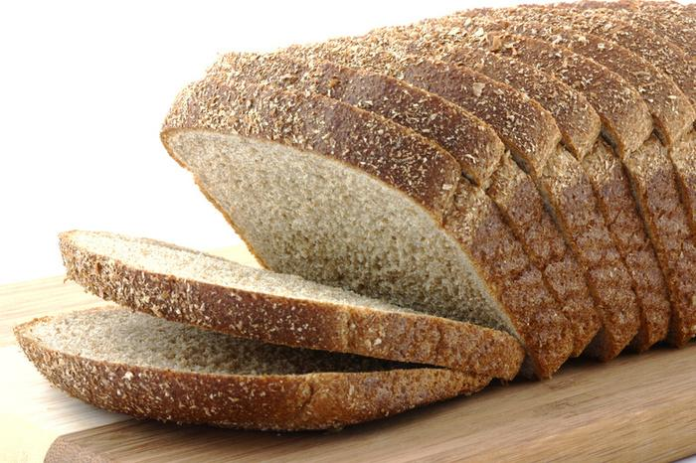

**2.** 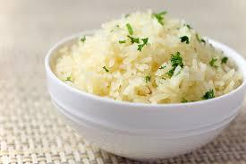

**3.** 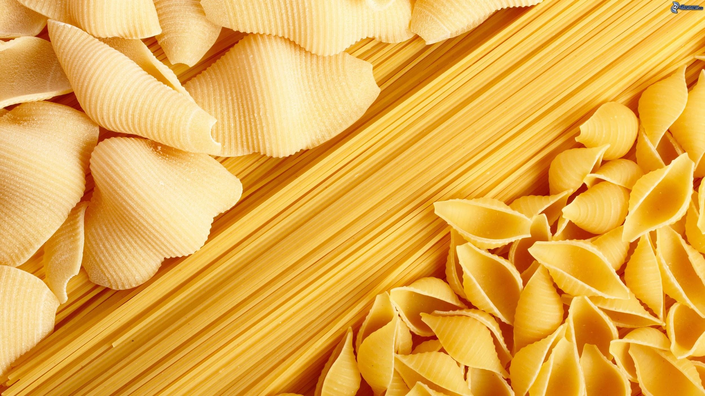

**4.** 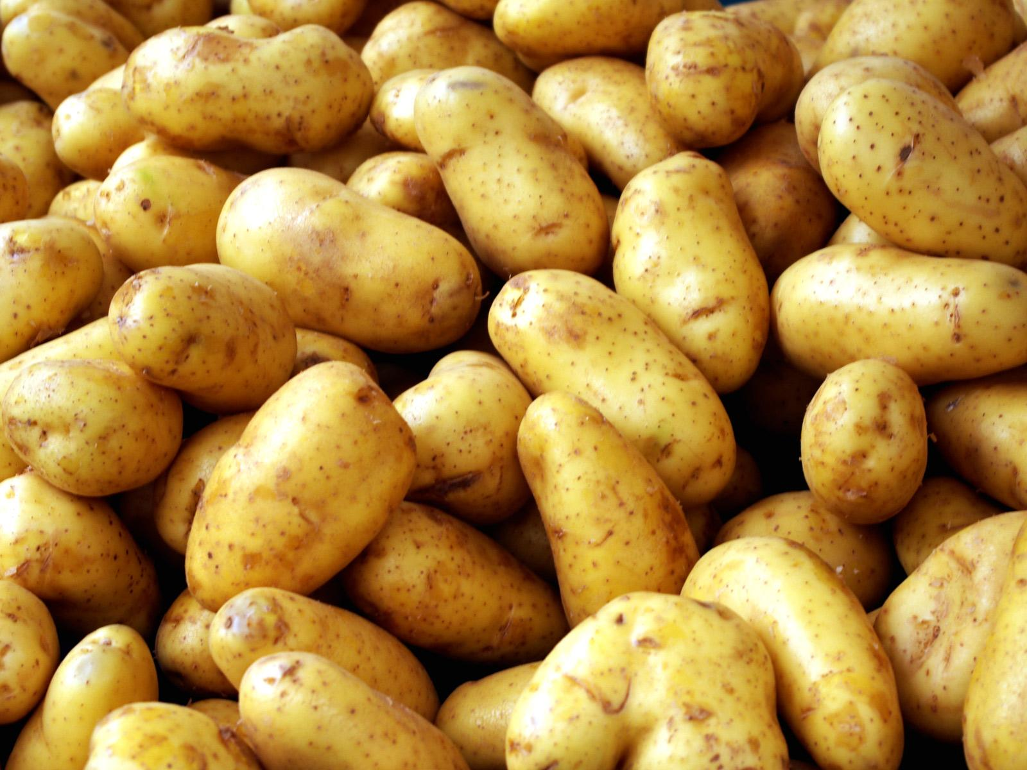

**List the Major Function(s)of the nutrients**

**function of carbohydrates  
1. Provide energy and regulation of blood glucose  
2. Sparing the use of proteins of energy**

**3. Breakdown of fatty acids and preventing ketosis  
4. Biological recognition processes  
Recommended Daily Intake (Based on a 2000 calorie Diet) How much are you supposed to have?  
We supposed to have 40-60% or 800calorie - 1200calorie per day.**

**Nutrient Specific Info**

|  |  |
| --- | --- |
| **Simple Carbs:  Defined: Sugars. It can be found in fruits. It gives only small nutritional value to the body.  Examples (Picture)**cookie733.jpg **Fast Burning Carb.  Explained: The fact that the simple chemcal structure allows it to be absorbed quickly.  Nutrient Quality (High or Low):Very low** | **Complex Carbs:  Defined: Made up of sugar molecules that are strung together in long, complex chains. Examples (Picture)**  Farfalle_Pasta.JPG **Slow Burning Carbs  Explained: Carbs that supply you with a sustained and steady delivery of energy.  Nutrient Quality (High or Low):Low** |

**Type 2 Diabetes and Simple Carbs?  
 Explain the Impact of Simple Sugars on Blood Sugar  
 Define Type 2 Diabetes   
 Health Consequences (Type 2 Diabetes)**

**Glycemic Index  
 is a scale that ranks carbohydrates by how much they raise blood glucose levels compared to a reference food.  
 3 High GI Foods - Ice-Cream , Rice , Bread  
 3 Low GI Foods- Banana, Pasta , Corn**

## **Fats Name of Persons (Prim ) Define/What is the Nutrient/Overview Quality food sources (What types of *healthy* food are high in this nutrient) Pictures 1.Chee**se

## 

## **2. Egg**

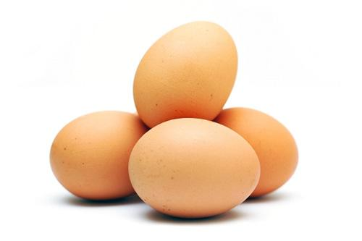

## **3**. Nuts

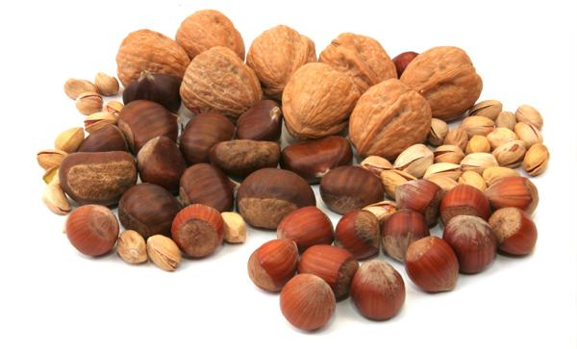

## **4. Avocado**

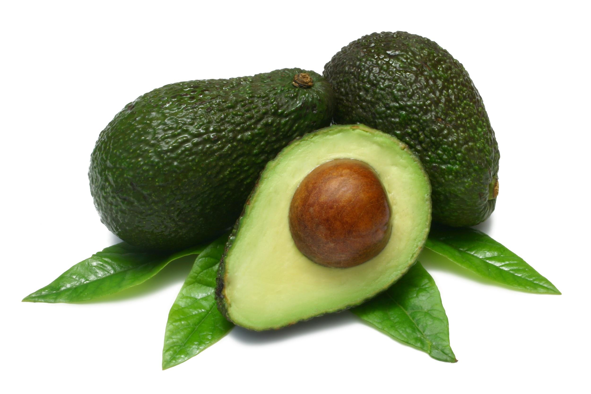

## **List the Major Function(s)of the nutrient 1. Gives energy 2. Maintain growth and repair 3. To process Vitamin A D E K. 4. For healt**hier skin and hair **Recommended Daily Intake (Based on a 2000 calorie Diet) How much are you suppos**e to take? **Nutrient Specific Info Saturated fats <10 grams per** day , Unsaturated 40-42 grams per day , Transfat <2 grams per day.

|  |  |  |
| --- | --- | --- |
| **UnSaturated Fat**  Food Sources Sunflower oil Picture(s) of Source      Heart Health   Stat or Explain Impact on Heart  Help reduce bad chloresterol level and lower the risk of heart disease. | **Saturated Fat**  Food Sources Meat,Egg,Dairy products Picture(s) of Source    Heart Health   Stat or Explain Impact on Heart  Recieve too much it can raise heart disease. | **Trans Fat**  Food Sources Doughnuts Picture(s) of Source      Heart Health   Stat or Explain Impact on Heart  It’s the factor to drive heart disease. |

**Proteins Name of Persons ( Mew )  
Define/What is the Nutrient/Overview**

**Substance in food that improtant to your body.Protein are one kind of building block of of body issue.  
Quality food sources (What types of *healthy* food are high in this nutrient)  
Pictures**

**1. Meat 2. Fish**

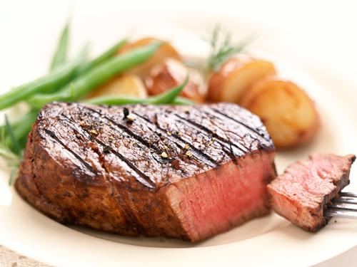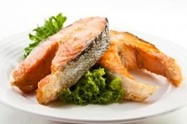 **3. Milk 4. Eggs**

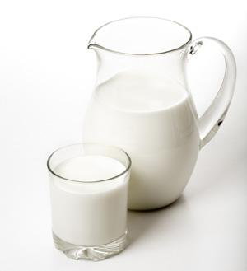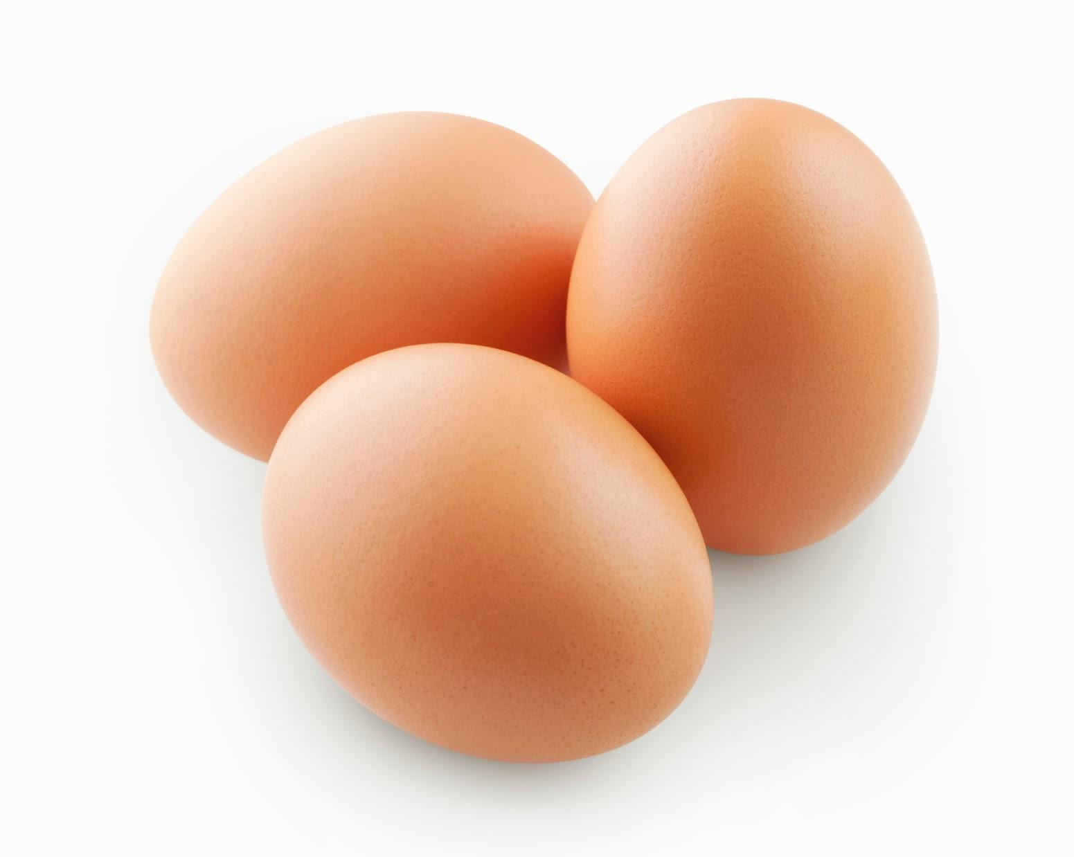

**List the Major Function(s)of the nutrient  
1. growth and repair of body tissue.  
2. provide energy to us  
3. Protein is involved in the creation of some hormones.  
4. Building muscle.  
Recommended Daily Intake (Based on a 2000 calorie Diet) How much are you supposed to have?**

* **It depend on daily activities. If you dont do hard exerecises or activities that require a lot energy then you only need 2000 cal./day.**

**Amino Acids Defined - small part of protein**

|  |  |
| --- | --- |
| **Complete Proteins:  Defined - is a source of** [**protein**](http://en.wikipedia.org/wiki/Protein) **that contains all nine essential amino acids  Examples (Pictures)**images.jpg | **Complex Carbs: is the carbohydrate that give us a lot of energy and last in a long period of time.    Examples (Pictures)**  iStock_000019290880XSmall.jpg |

**Vitamins Name of Persons (Pang)  
Define/What are these Nutrients/Overview**

**Vitamins is a chamical in food that didn,t give energy to our body. Human body need vitamins just a little amount but or human body need to have vitamins. If body lack of vitamins some organ or some system will work unproperly.  
Quality food sources (What types of *healthy* food are high in this nutrient)**

**Pictures   
1. Vitamins C** 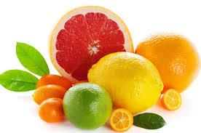

**2. Vitamins A**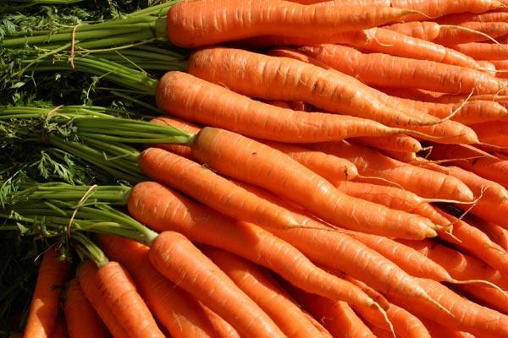

**3. Vitamins B**

**4.VitaminsD**

945932_663455347003937_81377241_n.jpg

**List the Major Function(s)of the nutrients  
1.support body growth and develop  
2.make body function properly  
3.protect body from illness  
4.make body work better  
  
Nutrient Specific Info**

|  |  |
| --- | --- |
| **Vitamins Fat Soluble**  **4 example ( A, D , E ,K)**  **Vs.**  **Water Soluble**  **3 Examples (All vitamins B, Vitamin C)** |  |

**Do you need to take a multivitamin?**

**We don’t need to take multivitamin in cause we get enough vitamins. Because, multivitamin it is an extrea vitamin. Moreover, our body didn’t want to much vitamins. In our daily life food did we eat is contain some amout of vitamins already. However, we should get enough vitamins for your body function properly.**

**Minerals Name of Persons( Pang )  
Define/What are these two Nutrients/Overview**

**MInerals is a organic substance that help our body to be stronger. Moreover, mineral is a substance that make some chamical in cell work faster.  
Quality food sources (What types of *healthy* food are high in this nutrient)  
- Sodium, Chloride, Potassium ,Calcium ,Phosphorus ,Magnesium ,Sulfer**

**Pictures   
1. Calcium**

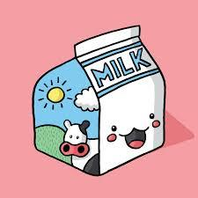

**2. Iodine**

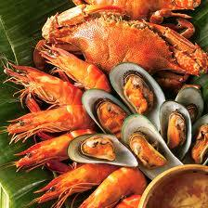

**3.Magnesium**

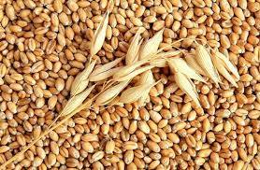

**4.Green Vegetable**

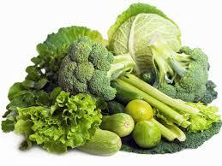

**List the Major Function(s)of the nutrients  
1.Help muscles relax and contract.  
2.For energy and endulance.  
3.Needed for energy metabolism  
4.For proper fluid balance nerve transmission and muscle contraction  
  
Nutrient Specific Info**

|  |  |
| --- | --- |
|  | **Minerals Macro Vs. Trace**  **3 Examples**  **(Sodium , Choride ,Potassium) = Macro**  **3 Examples**  **(Iron , Zinc , Iodine) = Trace** |

**\***

## **Water Name of Persons (** BB **) Define/What is the Nutrient/Overview**

## Water is a essential nutrient because it is required in amount that exceed the body’s ability to produce it. All biochemical reactions occur in water. It fills spaces between cells and help form structures of a large molecule such as protein and glycogen. Water is also required for digestion, absorbtion, dissloveing nutrient, and elimination of waste products. **Quality food sources (What types of *healthy* food are high in this nutrient) Pictures** water-background.jpg

## ág.gifwater1.jpgimages.jpeg

## **List the Major Function(s)of the nutrient 1. Protects body organ and** tissue. **2. Regulates body tem**p**erature. 3.** Carries nutrient and oxygen to cell. **4**. Helps dissolve minerals and other nutrients to make them accessible to the body. **Recommended Daily Intake (Based on a 2000 calorie Diet) How much are you supposed to have?**

The health authorities commonly recommend eight 8-ounce glasses, which equals about 2 liters,

or half a gallon.

## **Nutrient Specific Info** % of Body That is Water? 60% of the body contains water. How Much Do You Need? (Research vs. Myths) People need to drink water approximately 8 cups per day. How Do You Know You are Dehydrated? (Must be correct answer)

## Having dry mouth.

## Lowered blood pressure, headache, and dizziness

## Having dry skin

## Muscle fatigue

## Feeling thirsty

## feeling lethargic and irritable

|  |  |
| --- | --- |
| **Learning About Carbohydrates** You've probably seen ads for low-carb foods and diets, but kids and adults need **carbohydrates**(say: kar-bo-**hi**-draytz). Most foods contain carbohydrates, which the body breaks down into simple sugars — the major source of energy for the body. Two Types of Carbohydrates There are two major types of carbohydrates (or carbs) in foods: simple and complex.  **Simple carbohydrates:** These are also called simple sugars. Simple sugars are found in refined sugars, like the white sugar you'd find in a sugar bowl. If you have a lollipop, you're eating simple carbs. But you'll also find simple sugars in more nutritious foods, such as fruit and milk. It's better to get your simple sugars from food like fruit and milk. Why? Because sugar isn't added to these foods and they also contain vitamins, fiber, and important nutrients like calcium. A lollipop has lots of added sugar and doesn't contain important nutrients.  **Complex carbohydrates:** These are also called starches. Starches include grain products, such as bread, crackers, pasta, and rice. As with simple sugars, some complex carbohydrate foods are better choices than others. Refined (say: ree-**find**) grains, such as white flour and white rice, have been processed, which removes nutrients and fiber. But unrefined grains still contain thesevitamins and minerals. Unrefined grains also are rich in fiber, which helps your digestive system work well. Fiber helps you feel full, so you are less likely to overeat these foods. That explains why a bowl of oatmeal fills you up better than sugary candy with the same amount of calories as the oatmeal.  So which type of carbs should you eat? Both can be part of a healthy diet. How the Body Uses Carbohydrates When you eat carbs, your body breaks them down into simple sugars, which are absorbed into the bloodstream. As the sugar level rises in your body, the pancreas releases a hormone called insulin. Insulin is needed to move sugar from the blood into the cells, where the sugar can be used as a source of energy.  When this process goes fast — as with simple sugars — you're more likely to feel hungry again soon. When it occurs more slowly, as with a whole-grain food, you'll be satisfied longer. These types of complex carbohydrates give you energy over a longer period of time.  The carbs in some foods (mostly those that contain a lot of simple sugars) cause the blood sugar level to rise more quickly than others. Scientists have been studying whether eating foods that cause big jumps in blood sugar may be related to health problems like diabetes and heart disease.  You're probably already on the right track if you are limiting simple sugars (such as candy) and eating more complex carbohydrates (like vegetables, oatmeal, and whole-grain wheat bread).  Reviewed by: Mary L. Gavin, MD Date reviewed: September 2011 Available url: <http://kidshealth.org/kid/nutrition/food/carb.html#> |  |
| **Learning About Fats** Fat is a component in food. Some foods, including most fruits and vegetables, have almost no fat. Other foods have plenty of fat. They include nuts, oils, butter, and meats like beef.  The name — fat — may make it sound like something you shouldn't eat. But fat is an important part of a healthy diet. And little kids, especially, need a certain amount of fat in their diets so thebrain and nervous system develop correctly. That's why toddlers need to drink whole milk, which has more fat, and older kids can drink low-fat or skim milk. Doing the Math How much fat should you eat? Experts say kids older than 2 should get about 30% of their daily calories from fat. Here's how that works. Every day, you eat a certain amount of calories. For instance, some kids will eat 2,000 calories in a day. If 30% of 2,000 calories comes from fat, that means that 600 calories will come from fat. You can look at a food label to learn how many grams of fat are in a serving of a food. Labels also list the total calories from fat.  One way to reach this goal is to eat foods that are about 30% fat. But few foods contain exactly 30% fat. Instead, you can eat a mix of foods — some with higher percentages of fat and some with lower percentages — so that you still meet that goal of 30% of calories from fat.  Here's a sample menu to help you reach that goal. It includes a peanut butter and jelly sandwich, milk, and an apple. The peanut butter is high in fat, but it's a nutritious food and the overall total from the whole meal is about 30% from fat.   * Two slices of bread = 13% fat (30 of 230 calories from fat) * Two tablespoons of peanut butter = 75% fat (140 of 190 calories from fat) * One tablespoon of jelly = 0% fat (0 of 50 calories from fat) * One cup of 1% milk = 18 % (20 of 110 calories from fat) * Apple = 0% (0 of 80 calories from fat)   Total = 29% fat (190 of 660 calories from fat) Types of Fat You might see ads for foods that say they're "low-fat" or "fat-free." Lower-fat diets have been recommended for health and to help people lose weight. But nutrition experts are finding that fats are more complicated and that some kinds of fat are actually good for your health. As a bonus, fat in food helps people feel satisfied, so they don't eat as much.  But that doesn't mean a high-fat diet will be good for you. And some fats are better than others. Here are the three major types:  **Unsaturated fats:** These are found in plant foods and fish. These may be good for heart health. The best of the unsaturated fats are found in olive oil, peanut oil, canola oil, albacore tuna, and salmon.  **Saturated fats:** These fats are found in meat and other animal products, such as butter, cheese, and all milk except skim. Saturated fats are also in palm and coconut oils, which are often used in commercial baked goods (the kind you buy at the store). Eating too much saturated fat can raise blood cholesterol levels and increase the risk of heart disease.  **Trans fats:** These fats are found in margarine, especially the sticks. Trans fats are also found in certain foods that you buy at the store or in a restaurant, such as snack foods, baked goods, and fried foods. When you see "hydrogenated" or "partially hydrogenated" oils on an ingredient list, the food contains trans fats. Trans fats are also listed on the food label. Like saturated fats, trans fats can raise cholesterol and increase the risk of heart disease. Why Do We Need Fat? Dietary fat helps a kid's body grow and develop like it should. Fats fuel the body and help absorb some vitamins. They also are the building blocks of hormones and they insulate nervous system tissue in the body.  So fat is not the enemy, but you'll want to choose the right amount — and the right kind — of fat. If you're getting most of your fat from lean meats, fish, and heart-healthy oils, you've already made fat your friend!  Reviewed by: Mary L. Gavin, MD Date reviewed: October 2011 Available url: <http://kidshealth.org/kid/stay_healthy/food/fat.html?tracking=K_RelatedArticle#> **Learning About Proteins**You probably know you need to eat protein, but what is it? Many foods contain protein (say: pro-teen), but the best sources are beef, poultry, fish, eggs, dairy products, nuts, seeds, and legumes like black beans and lentils.Protein builds, maintains, and replaces the tissues in your body. (Not the tissues you blow your nose in! We mean the stuff your body's made up of.) Your muscles, your organs, and your immune system are made up mostly of protein.Your body uses the protein you eat to make lots of specialized protein molecules that have specific jobs. For instance, your body uses protein to make hemoglobin (say: hee-muh-glow-bin), the part of red blood cells that carries oxygen to every part of your body.Other proteins are used to build cardiac muscle. What's that? Your heart! In fact, whether you're running or just hanging out, protein is doing important work like moving your legs, moving your lungs, and protecting you from disease.All About Amino AcidsWhen you eat foods that contain protein, the digestive juices in your stomach and intestine go to work. They break down the protein in food into basic units, called amino acids (say uh-mee-no a-sids). The amino acids then can be reused to make the proteins your body needs to maintain muscles, bones, blood, and body organs.Proteins are sometimes described as long necklaces with differently shaped beads. Each bead is a small amino acid. These amino acids can join together to make thousands of different proteins. Scientists have found many different amino acids in protein, but 22 of them are very important to human health.Of those 22 amino acids, your body can make 13 of them without you ever thinking about it. Your body can't make the other nine amino acids, but you can get them by eating protein-rich foods. They are called essential amino acids because it's essential that you get them from the foods you eat.Different Kinds of ProteinProtein from animal sources, such as meat and milk, is called complete, because it contains all nine of the essential amino acids. Most vegetable protein is considered incomplete because it lacks one or more of the essential amino acids. This can be a concern for someone who doesn't eat meat or milk products. But people who eat a vegetarian diet can still get all their essential amino acids by eating a wide variety of protein-rich vegetable foods. |  |
| **Reviewed by: Mary L. Gavin, MD Date reviewed: October 2011 Available url:** [**http://kidshealth.org/kid/nutrition/food/protein.html#cat20132**](http://kidshealth.org/kid/nutrition/food/protein.html#cat20132)**Vitamins and Minerals** Breakfast cereals advertise that they're packed with vitamins and minerals. Sports drinks claim they can rev up your flagging energy with a jolt of vitamins or minerals (sorry, but even powerful vitamins and minerals can't act that fast!). You know vitamins and minerals are good for you. But which ones does your body really need? And is it possible to get too much of a good thing? What Are Vitamins and Minerals? Vitamins and minerals make people's bodies work properly. Although you get vitamins and minerals from the foods you eat every day, some foods have more vitamins and minerals than others.  Vitamins fall into two categories: fat soluble and water soluble. The **fat-soluble** vitamins — A, D, E, and K — dissolve in fat and can be stored in your body. The **water-soluble** vitamins — C and the B-complex vitamins (such as vitamins B6, B12, niacin, riboflavin, and folate) — need to dissolve in water before your body can absorb them. Because of this, your body can't store these vitamins. Any vitamin C or B that your body doesn't use as it passes through your system is lost (mostly when you pee). So you need a fresh supply of these vitamins every day.  Whereas vitamins are organic substances (made by plants or animals), minerals are inorganic elements that come from the soil and water and are absorbed by plants or eaten by animals. Your body needs larger amounts of some minerals, such as calcium, to grow and stay healthy. Other minerals like chromium, copper, iodine, iron, selenium, and zinc are called **trace minerals** because you only need very small amounts of them each day. What Do Vitamins and Minerals Do? Vitamins and minerals boost the immune system, support normal growth and development, and help cells and organs do their jobs. For example, you've probably heard that carrots are good for your eyes. It's true! Carrots are full of substances called **carotenoids** that your body converts into vitamin A, which helps prevent eye problems.  Another vitamin, vitamin K, helps blood to clot (so cuts and scrapes stop bleeding quickly). You'll find vitamin K in green leafy vegetables, broccoli, and soybeans. And to have strong bones, you need to eat foods such as milk, yogurt, and green leafy vegetables, which are rich in the mineral calcium.  Teen Health, Reviewed by: [Mary L. Gavin, MD](http://kidshealth.org/parent/misc/reviewers.html). Date reviewed: March 2013 Available url: <http://kidshealth.org/teen/food_fitness/nutrition/vitamins_minerals.html#> |  |

# **Why Drinking Water Is the Way to Go**

What do you, the trees, and a hamster have in common? Give up? You all need water. All living things must have water to survive, whether they get it from a water fountain, a rain cloud, or a little bottle attached to the side of a hamster cage.

Without water, your body would stop working properly. Water makes up more than half of your body weight and a person can't survive for more than a few days without it. Why? Your body has lots of important jobs and it needs water to do many of them. For instance, your blood, which contains a lot of water, carries oxygen to all the cells of your body. Without oxygen, those tiny cells would die and your body would stop working.

Water is also in lymph (say: **limf**), a fluid that is part of your immune system, which helps you fight off illness. You need water to digest your food and get rid of waste, too. Water is needed for digestive juices, urine (pee), and poop. And you can bet that water is the main ingredient in perspiration, also called sweat.

In addition to being an important part of the fluids in your body, each cell depends on water to function normally.

Your body doesn't get water only from drinking water. Any fluid you drink will contain water, but water and milk are the best choices. Lots of foods contain water, too. Fruit contains quite a bit of water, which you could probably tell if you've ever bitten into a peach or plum and felt the juices dripping down your chin! Vegetables, too, contain a lot of water — think of slicing into a fat tomato from the garden or crunching into a crisp stalk of celery.

### How Much Is Enough?

Since water is so important, you might wonder if you're drinking enough. There is no magic amount of water that kids need to drink every day. Usually, kids like to drink something with meals and should definitely drink when they are thirsty. But when it's warm out or you're exercising, you'll need more. Be sure to drink some extra water when you're out in warm weather, especially while playing sports or exercising.

When you drink is also important. If you're going to sports practice, a game, or just working out or playing hard, drink water before, during, and after playing. Don't forget your water bottle. You can't play your best when you're thinking about how thirsty you are!

When your body doesn't have enough water, that's called being dehydrated. Dehydration also can keep you from being as fast and as sharp as you'd like to be. A bad case of dehydration can make you sick. So keep that water bottle handy when the weather warms up! Not only does water fight dehydration, but it's awfully refreshing and has no calories.

Your body can help you stay properly hydrated by regulating the amount of water in your system. The body can hold on to water when you don't have enough or get rid of it if you have too much. If your pee has ever been very light yellow, your body might have been getting rid of excess water. When your pee is very dark yellow, it's holding on to water, so it's probably time to drink up.

You can help your body by drinking when you're thirsty and drinking extra water when it's warm out. Your body will be able to do all of its wonderful, waterful jobs and you'll feel great!

**Kids Health Reviewed by: Mary L. Gavin, MD Date reviewed: October 2012 Available Url:** <http://kidshealth.org/kid/nutrition/food/water.html#cat20132>